|  |
| --- |
|  |
| KEELER User Manual |
| **Version 01.01.02** |



**Revision History**

|  |  |  |  |
| --- | --- | --- | --- |
| **Version #** | **Description** | **Date** | **Done By** |
| 01.01.01 | Write KEELER user guide | **June 1, 2015** | Nirav |
| 01.01.02 | Formatting and edit some content & FAQ | **June 5, 2015** | Nirav |
|  |  |  |  |
|  |  |  |  |
|  |  |  |  |
|  |  |  |  |

Table of Contents

1. General Description 6

1.1. Introduction 6

1.2. Purpose 6

1.3. Scope 6

2. Definition(s) and Abbreviation(s) 7

3. Reference(s) 8

4. Installation of SR KEELER 9

4.1. Tools Required 9

4.2. Safety 10

4.3. Install SR KEELER 11

4.4. SR KEELER detail for different buttons and LED’s 12

5. Symbol Explanations for KEELER 13

6. SR KEELER Overview 14

6.1. Local Mode 14

6.2. Remote Mode 14

7. Download SR Smart App for iOS 15

7.1. Download the SR Smart App through App StoreSM 15

8. Download SR Smart app for Android 17

8.1. Download the SR Smart App through Play StoreSM 17

9. Register and Operate SR KEELER 19

9.1. Register Device using Scan “QR Code” 19

9.2. Register Device manually 21

10. Operate SR KEELER using SR Smart App 23

11. Check Status of your SR KEELER 24

12. Setting Management 25

12.1. SR Device Settings 25

12.1.1. Device Name 26

12.1.2. Battery 26

12.1.3. Audio 27

12.1.4. Auto Lock Timer 27

12.1.5. Notification 28

12.1.6. Set Location 29

12.1.7. User Pin 30

12.1.8. LAN Scan Timer 31

12.1.9. Audit Trail 32

12.2. SR App Settings 33

12.2.1. Set Admin PIN 34

12.2.2. Set User PIN 35

12.2.3. Sound Notification 36

12.3. About SR Device 37

12.3.1. Firmware Upgrade 38

13. Device Management 40

13.1. Add Device 40

13.2. Rename Device 41

13.3. Delete Device 42

13.4. Status All 43

13.5. Switching between devices 44

14. Users Management 45

14.1. Add User 46

14.1.1. Add User from Contact Book 46

14.1.2. Add User Manually 49

14.1.3. About Access Device 51

14.1.4. Delete Access Device 52

14.2. Keyfob 53

14.2.1. Add Keyfob 54

14.2.2. About Keyfob Device 56

14.2.3. Delete Keyfob Device 57

15. Help Option 58

15.1. Help 58

15.2. Developer Options 59

15.2.1. Camera Settings 59

15.2.2. Battery Information 61

16. SR Portal 62

16.1. Sign up for SR Portal 62

16.2. New Customer Registration 63

16.3. Activate Your Account 64

16.4. Sign-In Page 65

16.5. Secure Home Page 66

16.6. Register SR device 67

16.7. All SR Devices 69

16.8. Invite a New User Device 70

16.9. All Users 71

16.10. Audit Logs 72

16.11. Register SR Bridge 73

16.12. Configure SR Bridge 74

16.13. Dashboard Option 76

16.14. Invites Option 77

17. Remote Mode 78

17.1. Lock operation 78

17.2. Unlock operation 79

17.3. Status operation 80

17.4. Remote Pairing 82

18. Update the SR Smart® App 83

18.1. Update the SR Smart® App for iOS devices 83

18.2. Update the SR Smart® App for Android devices 83

19. Remove the SR SmartTM app from your Smartphone 83

20. Factory Reset 84

21. SR KEELER LED Indication 85

22. Keyfob LED Indication 86

23. Frequently Ask Questions 87

# General Description

## Introduction

This document provides detailed information regarding SecuRemote® KEELER device and application.

## Purpose

This document provides installation, configuration and operation information for the SecuRemote® KEELER device using iOS devices and Android devices.

**Note:** The application will run on all versions of the Bluetooth version 4.0 and above. The application will also run on iOS 6 and Android OS version 4.3 onwards.

* iPhone 4S onwards
* iPad 3rd Generation onwards
* iPad Mini
* iPod 5th Generation onwards.

Supports smart phone for Android™ OS 4.3 and higher operating system version.

* Motorola®
* HTC®
* Samsung®
* Google™
* Dell®
* Android™ Tablet*

## Scope

This document covers all information required for a user to operate the SR KEELER.

# Definition(s) and Abbreviation(s)

|  |  |
| --- | --- |
| **Abbreviation** | **Definition** |
| SR | SecuRemote® |
| BLE | Bluetooth Low Energy |
| SR Device | Device which used SecuRemote® Technology |
| App (app) | Application |
| SR KEELER | SecuRemote KEELER device |
| Admin | Administrator |
| Admin PIN | Administrator PIN |
| LED | Light Emitting Diode |
| SR Smart | SecuRemote® Smart |
| UDI Portal | UDI Portal (Online Server) |
| BT | Bluetooth® |
| m sec | Millisecond |
| sec | Seconds |
| Async Event | Asynchronous Event |

# Reference(s)

|  |  |
| --- | --- |
| **Document Number** | **Title** |
|  |  |
|  |  |
|  |  |

# Installation of SR KEELER

## Tools Required

Tool Letters will appear in figures

## 

Hammer

Wire stripper

Drill

Tape measure

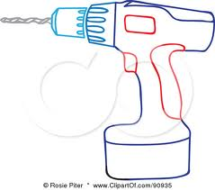

Above Tools as needed

Ladder

Tape

Flat Blade screwdriver

Pencil

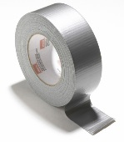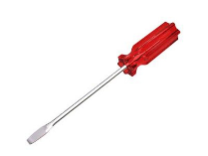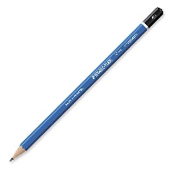

Phillips screwdriver

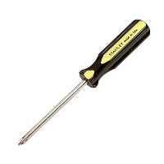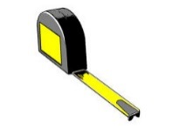

A

B

C

D



E

## Safety

## Install SR KEELER

## SR KEELER detail for different buttons and LED’s

* **LED Indication**
* **Blue** **LED** – Blinks when smartphone is connected to SR KEELER
* **Red** **LED** – Glows as door lock
* **Green LED** – Glows as door unlock

# Symbol Explanations for KEELER

|  |  |
| --- | --- |
|  | The SR Smart App is performing an operation |
|  | Press this button to check the status of the selected device |
|  | The device is in “Unlocked” position |
|  | The device is in “Locked” position |

# SR KEELER Overview

SR KEELER represents a new era of user-friendly security, control and convenience. It will provide many smart features that are not possible with standard conventional door lock. Here is a list of key features that are provided by this SR KEELER.

* 1. Operate SR KEELER using SR Smart application installed in iOS or Android devices. User can operate it within radius of up to 80 feet from SR KEELER without obstacles in Local Mode.
  2. User can operate device from remote location.
  3. User can operate device by Keyfob within 40 feet range of device.
  4. Provide access to other users.
  5. Notification alert which is triggered if you have forget to lock door and moved a mile away from the SR device location.
  6. Audit trail shows last 255 operations in smartphone with detail about each operation executed by any user.
  7. Configure user PIN so it prompts user to enter PIN every time user operates SR KEELER.
  8. User can upgrade firmware from SR Smart app.
  9. User can manage other user and device access settings from SecuRemote® Portal.

**How it works**

The SecuRemote® Smart app uses unique technology to transparently deliver powerful communication, authentication and functionality. The communication process begins when the primary User pairs his/her smartphone with a SecuRemote® device. The device registers the first users as an “Administrator”.

The Administrator can add 10 users (total of 10 users including Administrator/Keyfob) from his/her smartphone. Each user will receive a text Message with a link to download the App. Users can operate device within range of 80 feet in Local Mode depends on obstacle and Remote Location also.

## Local Mode

In this mode the communication between an SR device and a Smartphone is direct (between the two devices) using Bluetooth. Communication distance can be up to 80 feet depending on communication obstructions or the product application. This mode also supports Administration (Users are stored on the device itself), and Notification within Bluetooth range.

## Remote Mode

This mode offers all the previous benefits, but it also adds the ability for an SR device to be connected to SR online portal all the time, thus allowing a remote operation through SR online portal and event monitoring even when a user’s Smartphone is not present. This mode requires the use of an SR Bridge (Ethernet or CDMA) and an Internet Router with an Ethernet port. The SR Bridge setup and configuration are automatic. The SR Bridge uses Bluetooth to connect automatically with up to 24 SR devices wirelessly and directs the messaging to the SR online portal.

# Download SR Smart App for iOS

The SR Smart App will operate any SR device. Upon selecting the SR device user wants to operate the app will automatically display menu features and functionality for the selected device. The app is available for download through the App Store on your Smartphone. Search for "SR Smart" or “SecuRemote® Smart” word. The user should always download the SR Smart App directly from your smartphone’s store as this practice ensures future automatic app improvements/updates.

***Note:*** Make sure smartphone have the data connectivity to download app.

## Download the SR Smart App through App StoreSM

1. Click on “App Store Icon” to open app store. Refer Figure 1.
2. Search “SR Smart” keyword to find SR Smart® application. Refer Figure 2.
3. Click on “FREE” it will prompt for an Apple ID and password to begin SR Smart application download.

Refer Figure 3.

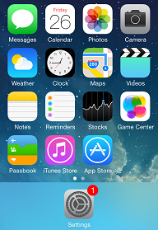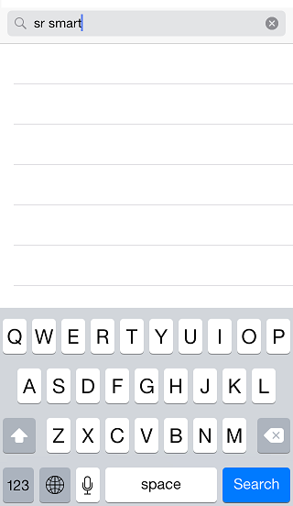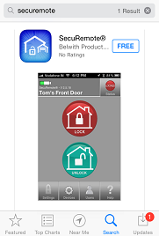

Figure 1: Smartphone Home Screen Figure 2: Search for SR Smart App Figure 3: App store search Screen

1. Click on “INSTALL”, to start installation of SR Smart application. Refer Figure 4.
2. By default, the “SR Smart® App icon” will be placed in the first available spot on your home screen.

Refer Figure 5.

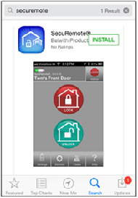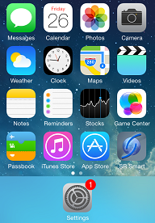

Figure 4: Installation Screen Figure 5: App Icon in Home Screen

# Download SR Smart app for Android

The SR Smart App will operate any SR device. Upon selecting the SR device user wants to operate the app will automatically display menu features and functionality for the selected device. The app is available for download through the Google Play Store on your Smartphone. Search for "SR Smart" or “SecuRemote® Smart” word. The user should always download the SR Smart App directly from your smartphone store as this practice ensures future automatic app improvements/updates.

***Note:*** Make sure smartphone have the data connectivity to download app.

## Download the SR Smart App through Play StoreSM

1. Click on “Play Store” icon to download SR App. Refer Figure 6
2. Search “SR Smart” keyword to find SecuRemote® Smart application. Refer Figure 7.
3. Click on “FREE” to begin SR Smart application download. Refer Figure 8.

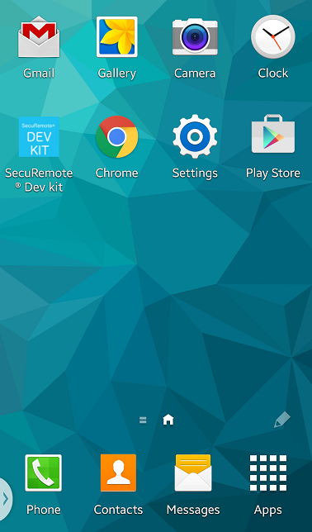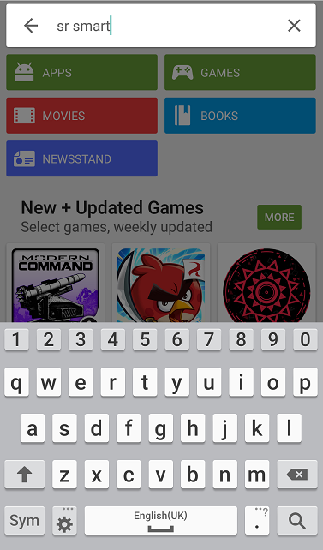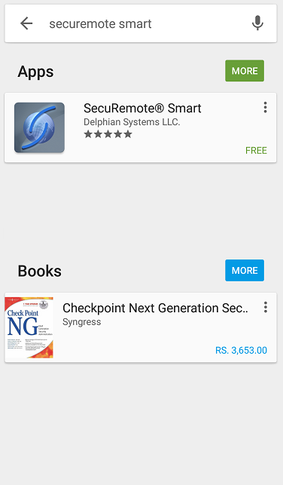

Figure 6: Smartphone Home Screen Figure 7: Search App Figure 8: App store search Screen

1. Click on “INSTALL”, to start installation of SR application. Refer Figure 9 .
2. By default, the “SR Smart® App icon” is placed in the first available spot on your home screen.

Refer Figure 10.

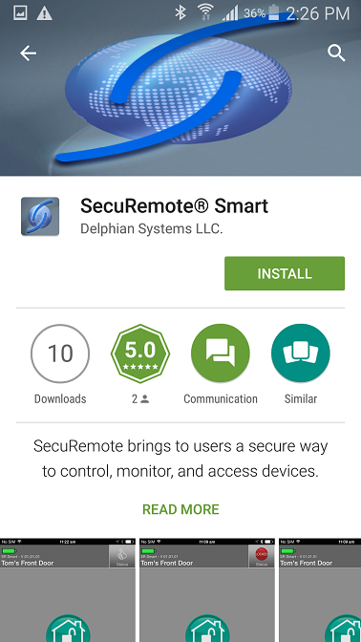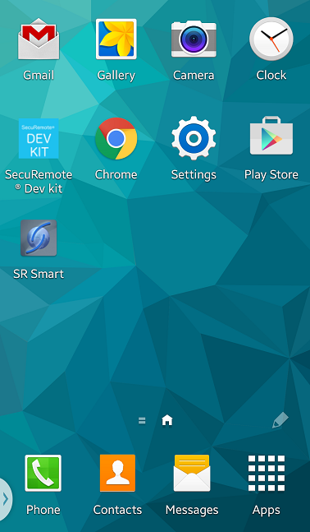

Figure 9: Install SR Smart App Figure 10: Installation Completed

# Register and Operate SR KEELER

After successful installation of “SR Smart” app, SR Smart app icon will appear on smartphone home screen. User can register SR device using “SCAN QR CODE” or “Enter SR # manually” options, upon successful activation user can pair and operate SR KEELER.

***Note:*** Make sure Data & Bluetooth connectivity is “ON”.

## Register Device using Scan “QR Code”

1. Click on the “SR Smart” app icon to launch the SR Smart app. “ADD SR DEVICE” screen will open.

Refer Figure 11.

1. Click on “SCAN QR CODE” option to add device, “Scan QR Code” will launch Camera to scan SR # from user manual or interior part of SR KEELER. Refer Figure 12 .
2. After QR Code is scanned successfully, SR Device information fill automatically in “ADD SR DEVICE” screen. Enter “SR Device Name” and click on “Create New Account” option. Refer Figure 13.

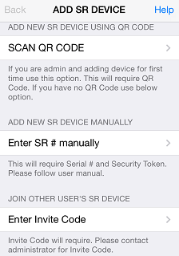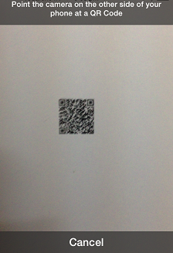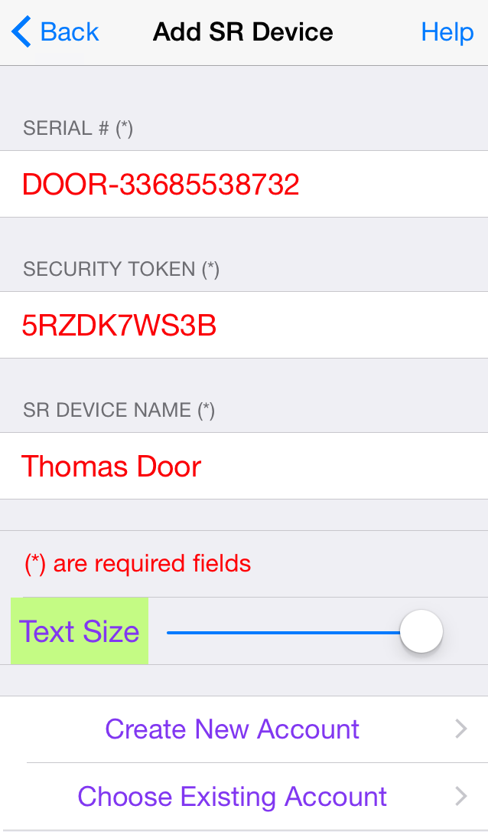

Figure 11: Add SR Device Figure 12: Scan QR Code Figure 13: Add SR Device

1. Enter all mandatory information in “Create SR Account” screen and click on “Register SR Device” option. Refer Figure 14.
2. It will display “Registering SR Device” activity message in “Create SR Account” screen. Refer Figure 15.
3. After device is registered on server it will redirect to app home screen and display “Garage is paired successfully, you can start operate it.” Toast message. Refer Figure 16.

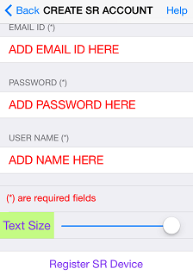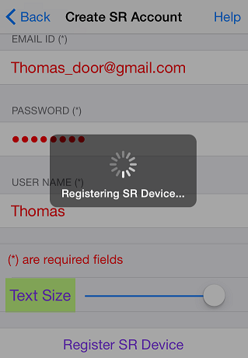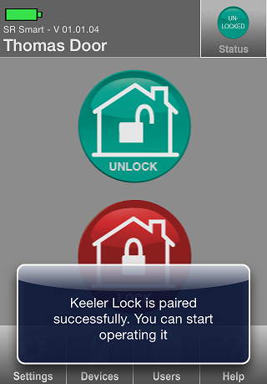

Figure 14: Create SR Account Figure 15: Registering SR Device Figure 16: Home Screen

## Register Device manually

1. Click on the “SR Smart” app icon to launch the SR Smart app. “ADD SR DEVICE” screen will open, Click on “Enter SR # manually” option to add device manually. Refer Figure 17.
2. It will display “ADD SR DEVICE” screen. Refer Figure 18.
3. Enter all require SR Device information and click on “Create New Account” or “Choose Existing Account” option to add SR Device information. Refer Figure 19.

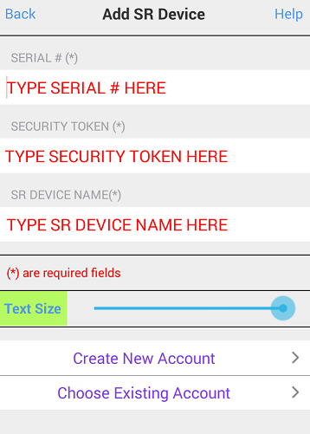

Figure 17: Add SR Device Figure 18: Add SR Device Figure 19: Add SR Device detail

1. It will display “Create SR Account” screen. Refer Figure 20.
2. Enter all require SR Account details and click on “Registering SR Device” option, it will appear “Registering SR Device” activation message. Refer Figure 21.
3. After device is registered on server it will redirect to app home screen and display “Keeler Lock is paired successfully. You can start operate it.” Toast message. Refer Figure 22.



Figure 20: Create SR Account Figure 21: Registering SR Device  Figure 22: Home Screen

# Operate SR KEELER using SR Smart App

1. Device Home Screen when device is not connected. Refer Figure 23.
2. Click on the “Lock” button to lock the Door, it will display “Door is Locked” toast message. Refer Figure 24.
3. Click on the “Unlock” button to unlock the Door, it will display “Door is Unlocked” toast message. Refer Figure 25.

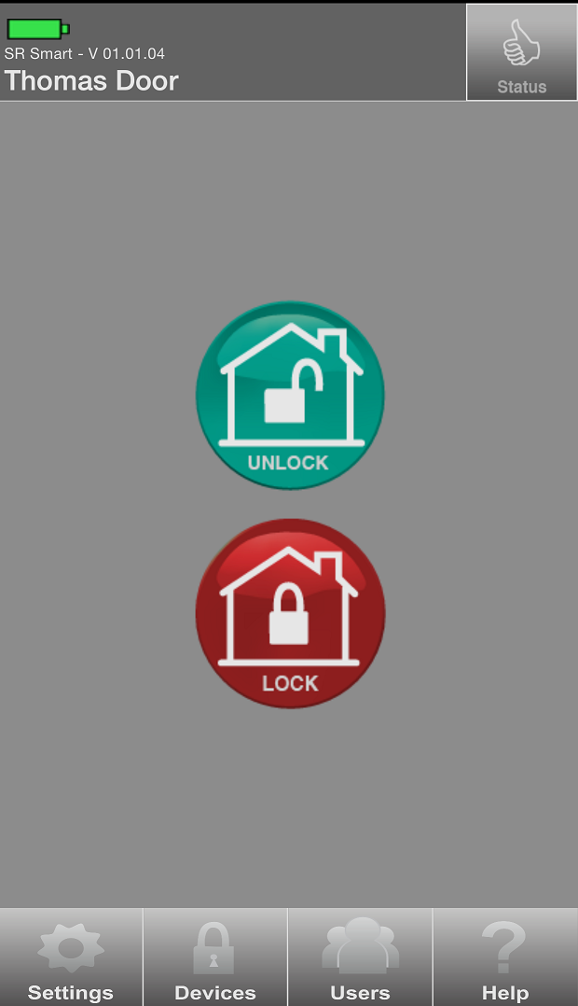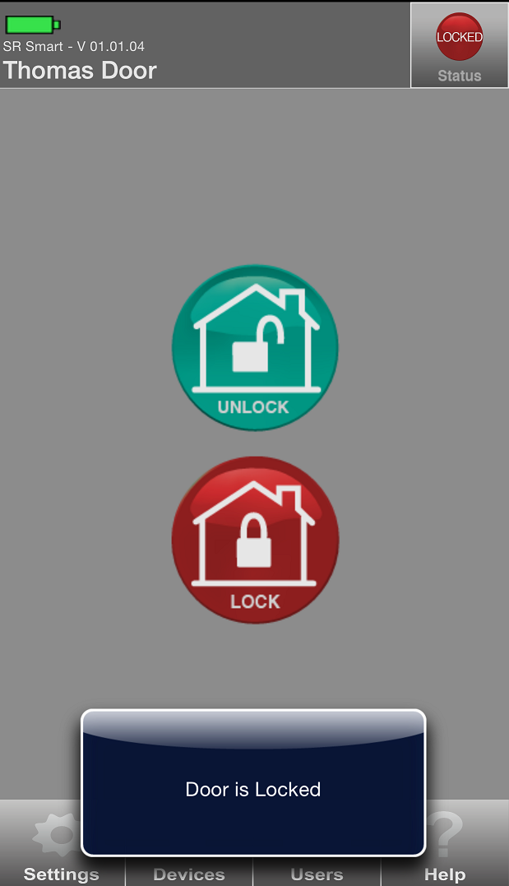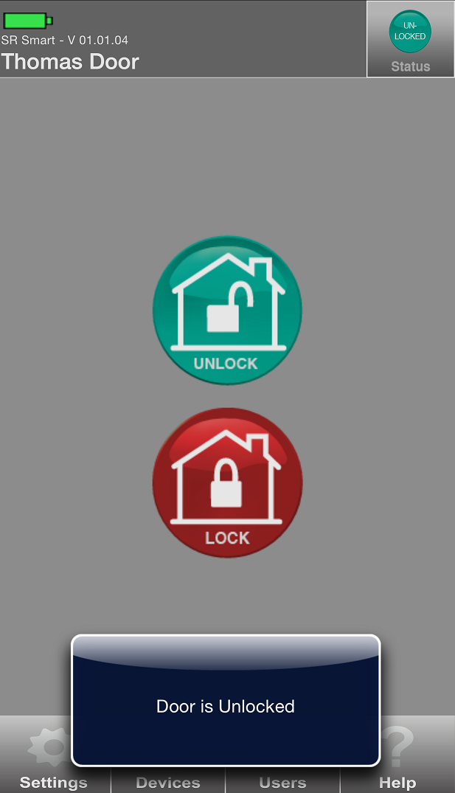

Figure 23: Home Screen Figure 24: Locked Message Figure 25: Unlocked Message

# Check Status of your SR KEELER

1. If the door is Unlocked then “Unlocked” will be indicated in Status. Refer Figure 26.
2. If the door is locked then “Locked” will be indicated in Status. Refer Figure 27.

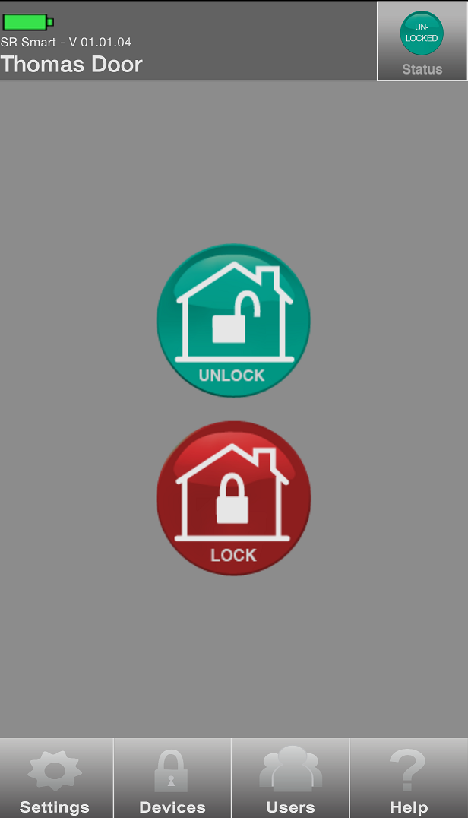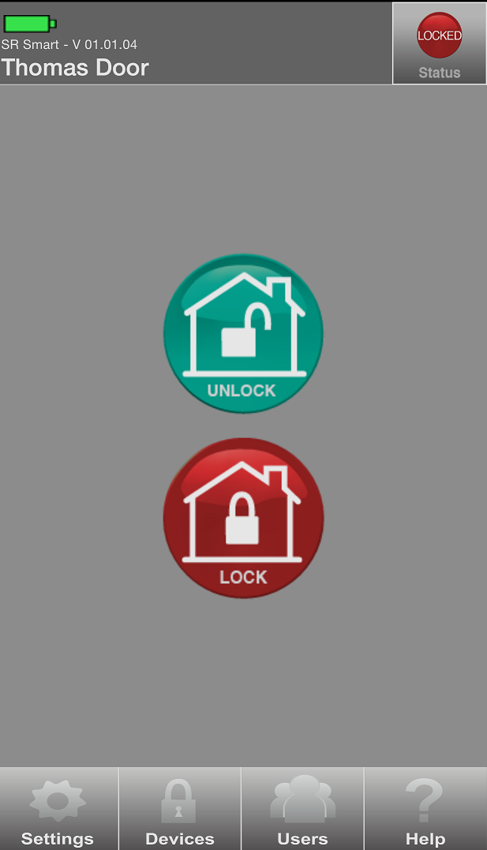

Figure 26: Unlocked Status Figure 27: Locked Status

# Setting Management

Admin user can set any SR KEELER parameter using this option. Go in “SR Device Settings” from “Settings” option to change settings.

## SR Device Settings

1. Click on “Settings” from Home screen and click on “SR Device Settings” option. Refer Figure 28.
2. It will display “Admin PIN” Screen, enter “Admin PIN”. Refer Figure 29.
3. It will display “SR Device Settings” screen. Refer Figure 30.

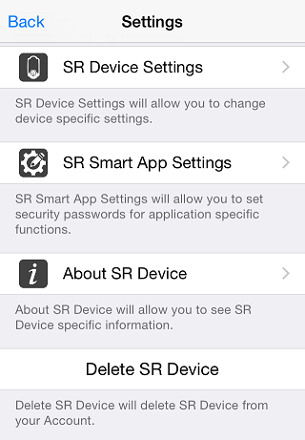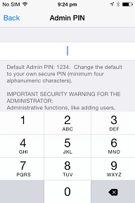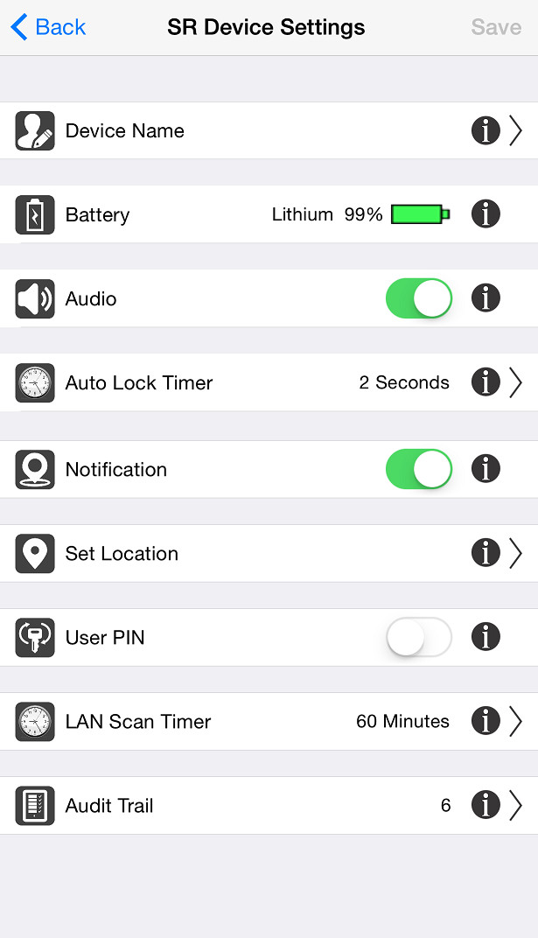

Figure 28: Settings Screen Figure 29: Admin PIN Figure 30: SR Device Settings

***Note:*** After change all the settings click on “Save” option to change settings.

## Device Name

1. Click on “Device Name” from “SR Device Setting” screen”. Refer Figure 31.
2. Enter the desired device name and click on “SAVE” option. Refer Figure 32.
3. It will redirect to “SR Device Settings” screen. Refer Figure 33.

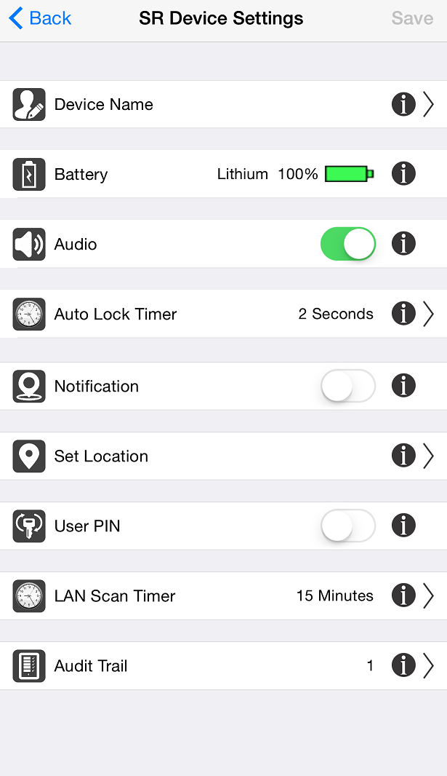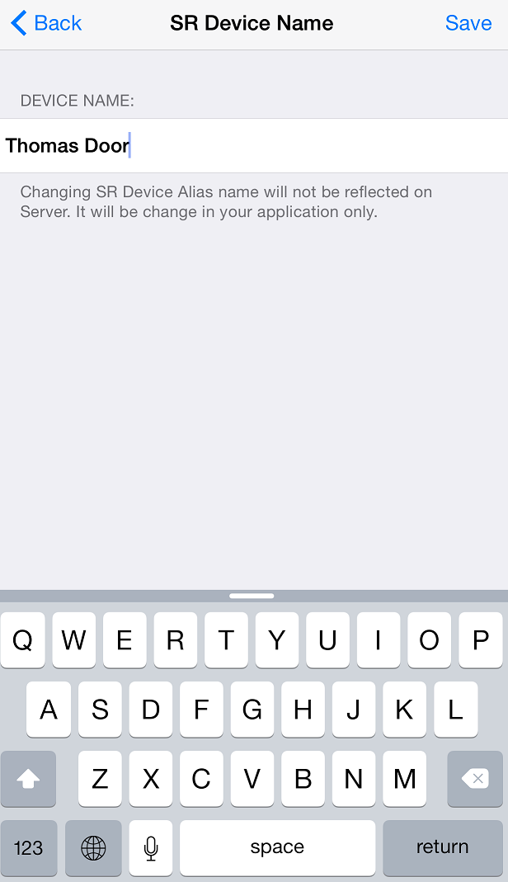

Figure 31: SR Device Settings Figure 32: SR Device Name Figure 33: SR Device Settings

## Battery

1. Click on “Settings” from Home screen and current “Battery” information of keeler device display in second option of “SR Device Settings” screen. Refer Figure 34



**Figure 34: Battery Information**

## Audio

In addition to light indicators Keeler locks are equipped with sound or audio that announces an operation.

This feature use to turn the audio on/off.

1. Use the toggle button to turn “Audio” on/off, select third option of “SR Device Setting” screen”.

Refer  **F**igure 35.

2. Click on “SAVE” option. Refer Figure 36.

3. “SR Device Settings is changed successfully” Confirmation toast message will display. Refer Figure 37.

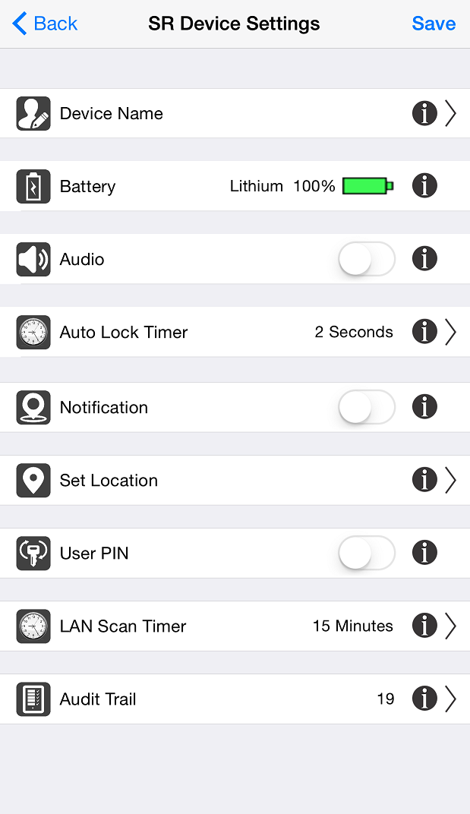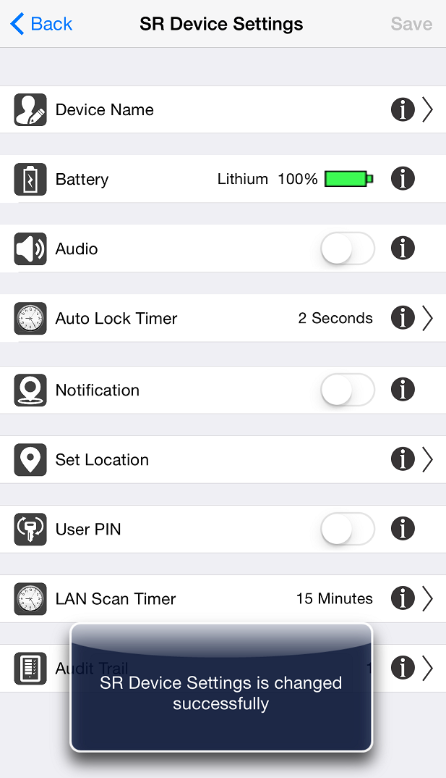

**Figure 35: SR Device Settings** **Figure 36: SR Device Settings** **Figure 37: Confirmation Message**

## Auto Lock Timer

1. Click on “Auto Lock Timer” from “SR Device Setting” screen. Refer Figure 38.

2. Select desired time to auto lock keeler device. Refer Figure 39.

3. “SR Device Settings is changed successfully” confirmation toast message will display. Refer Figure 40.

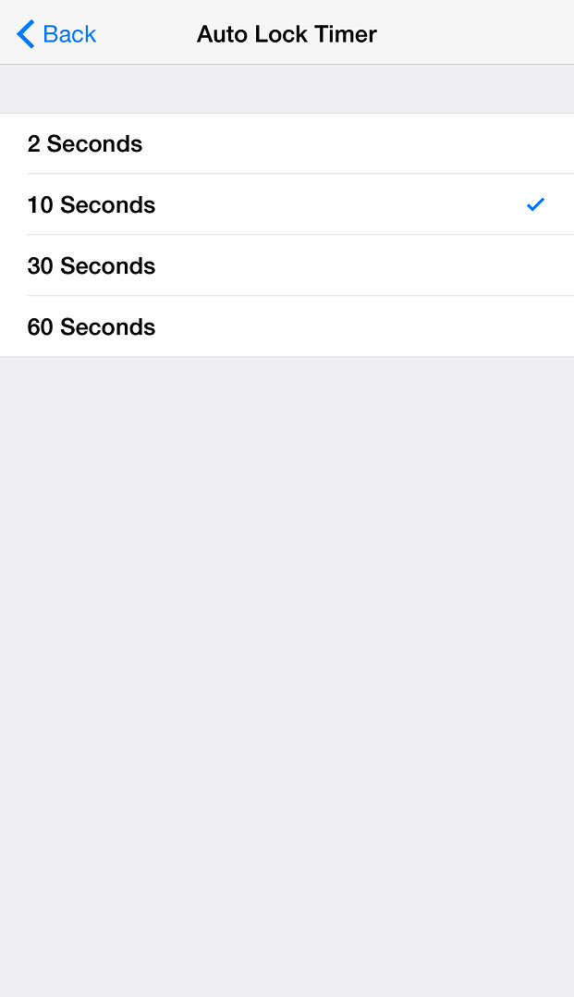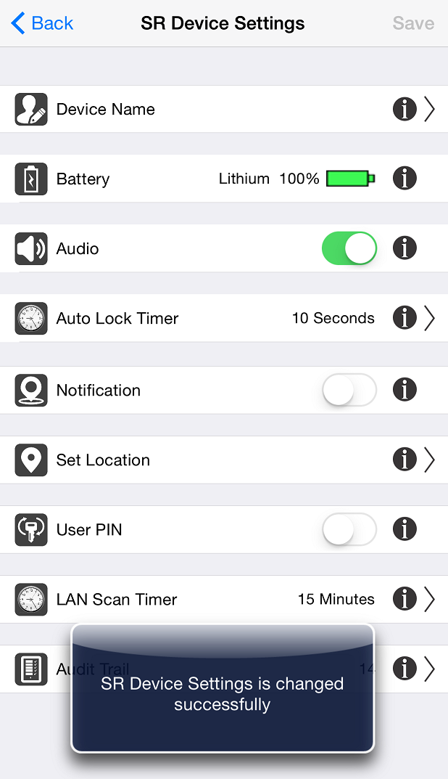

**Figure 38: SR Device Settings** **Figure 39: Auto Lock Timer** **Figure 40: Confirmation Message**

## Notification

Notification alert which is triggered if you have forget to close the door and moved a mile away from the SR device location. This is accomplished by SR tracking both the SR device status and your approximate location by using your smartphone's Location Services.

1. Click on SR Device Settings it will display SR Device Settings screen. Refer Figure 41
2. Enable “Notification” by using toggle button and click on “SAVE” button. Refer Figure 42
3. Notification message will display in smartphone notification screen. Refer Figure 43

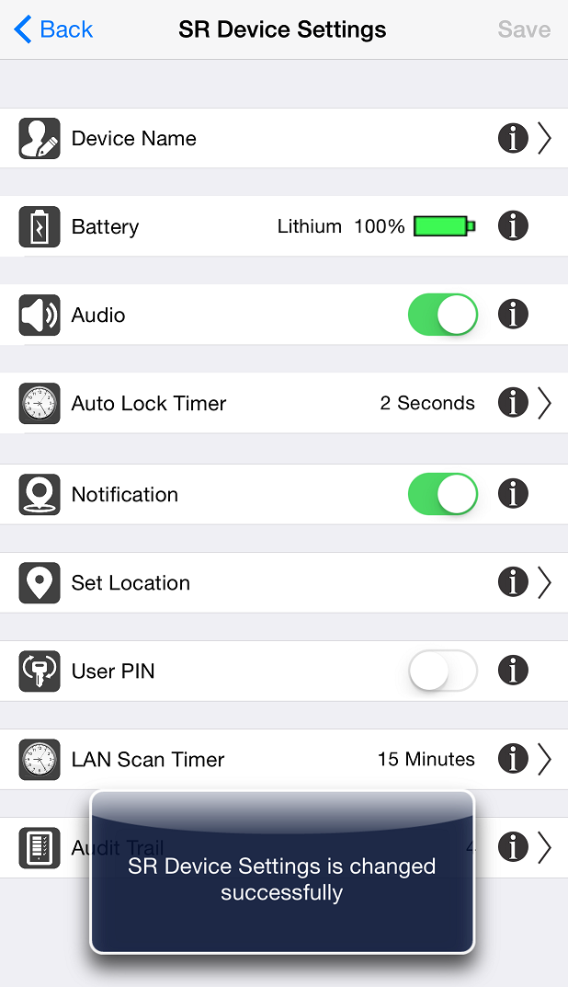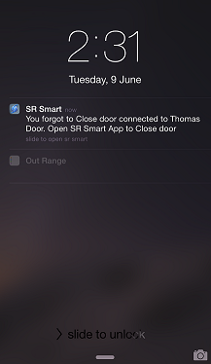

Figure 41: SR Device Settings Figure 42: Confirmation Message Figure 43: Notification

## Set Location

This feature is used to set the Current Location of your SR KEELER, which is necessary to enable “Notification” feature of SR KEELER.

1. Click on “Set Location” option and make sure your smartphone is at a location closest to the SR KEELER. Refer Figure 44.
2. Location Settings Screen will appear, click on “Set Location” option. Refer Figure 45.
3. Set Location Message will pop up with “cancel” and “Set Location” options, Click on “Set Location”. Refer Figure 46.

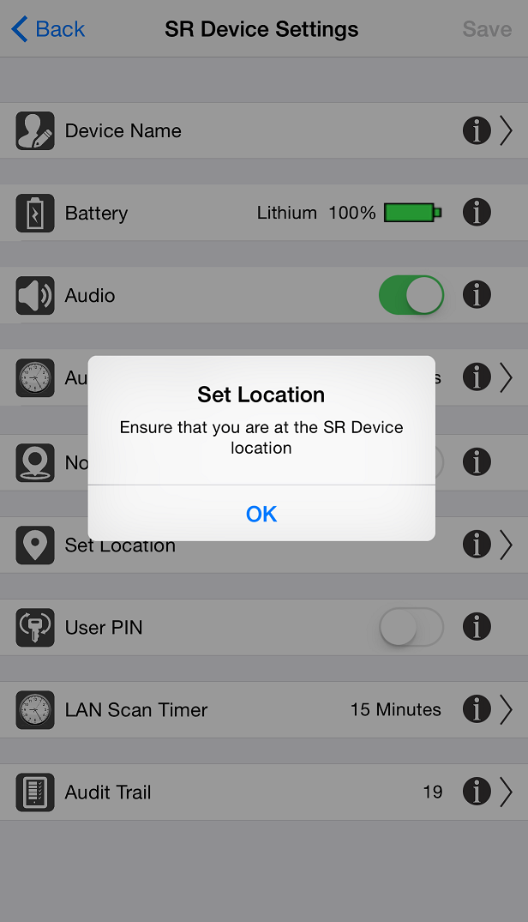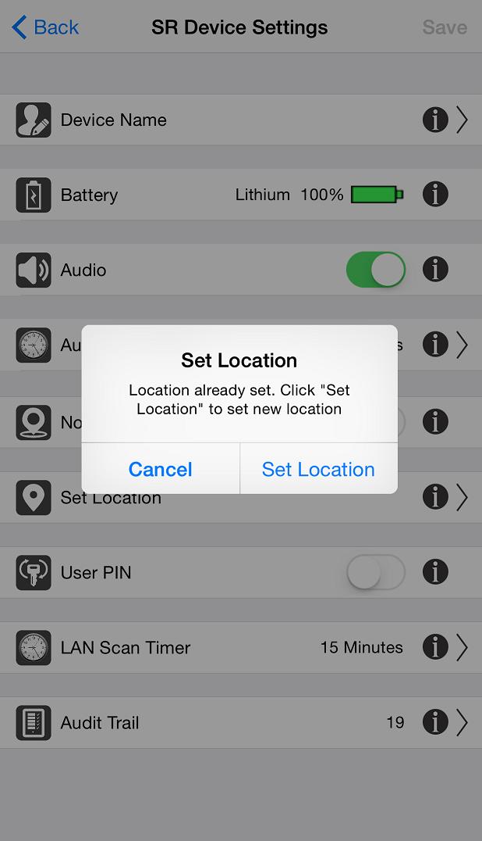

Figure 44: SR Device Settings Figure 45: Location Settings Screen Figure 46: Set Location Message

1. It will display “fetching current location” message. Refer Figure 47.
2. It will display “Device Location is set successfully. Region monitoring is enabled” message with “OK” Button. Refer Figure 48.

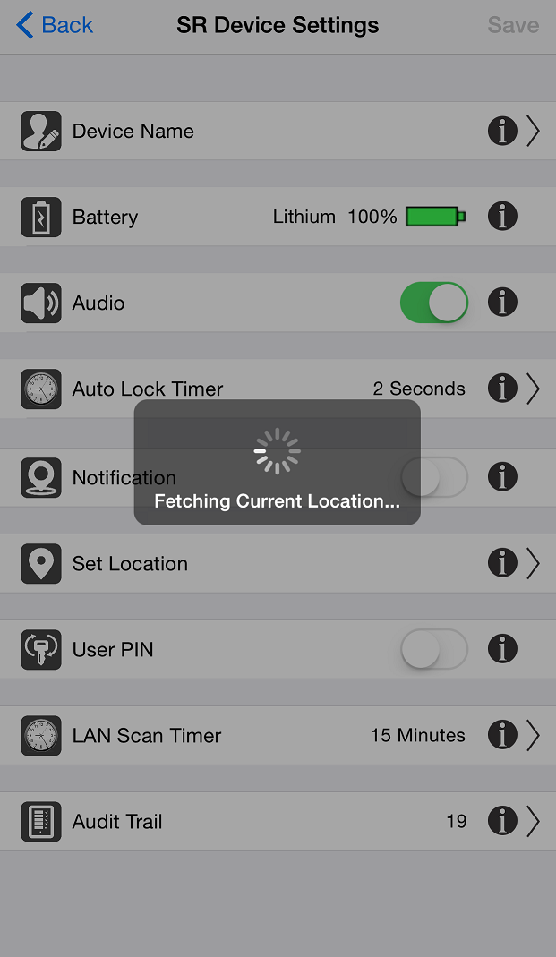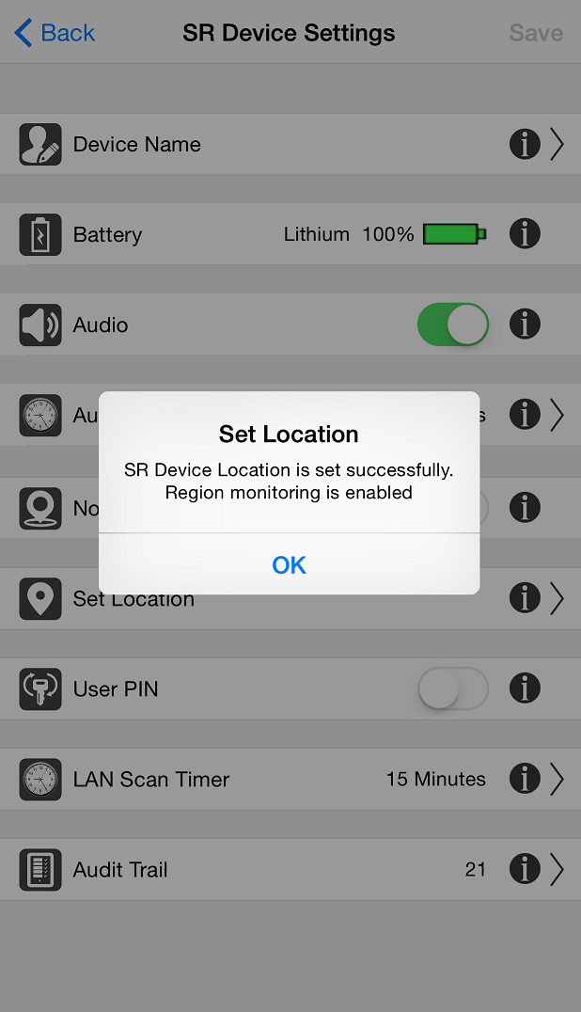

Figure 47: Location Settings Message   Figure 48: Set Location Message

## User Pin

Configure user PIN so it prompts user to enter PIN every time user operates SR KEELER.

This feature is used to Enable/Disable User Pin.

1. Click on SR Device Settings it will display SR Device Settings screen. Refer Figure 49.
2. Enable User PIN by using toggle button and click on “SAVE” option. Refer Figure 50.
3. “SR Device Settings is changed successfully” confirmation toast message will display. Refer Figure 51.

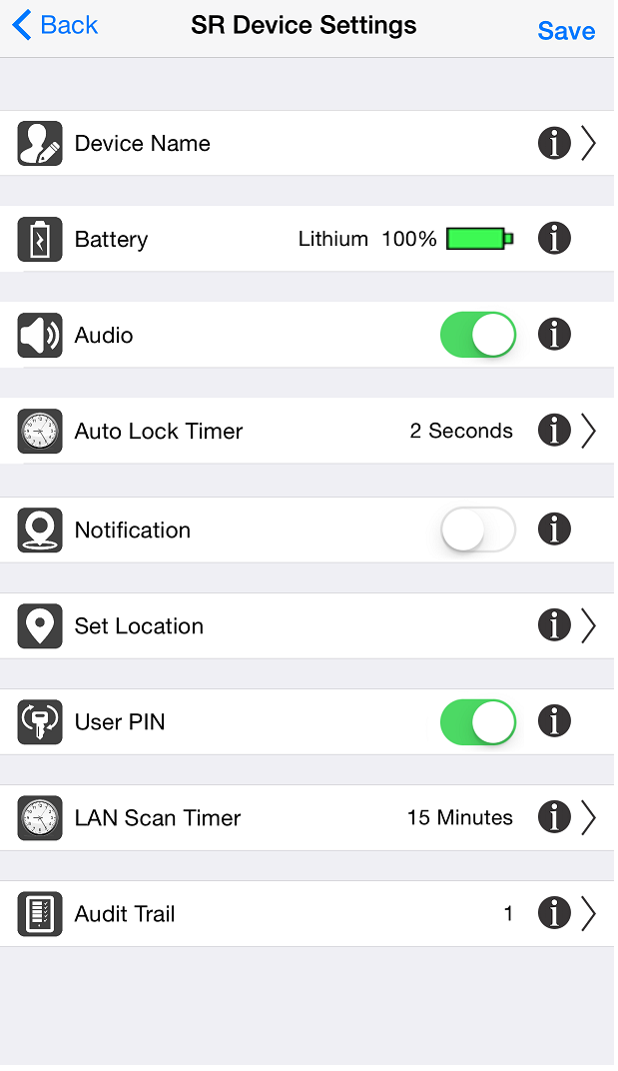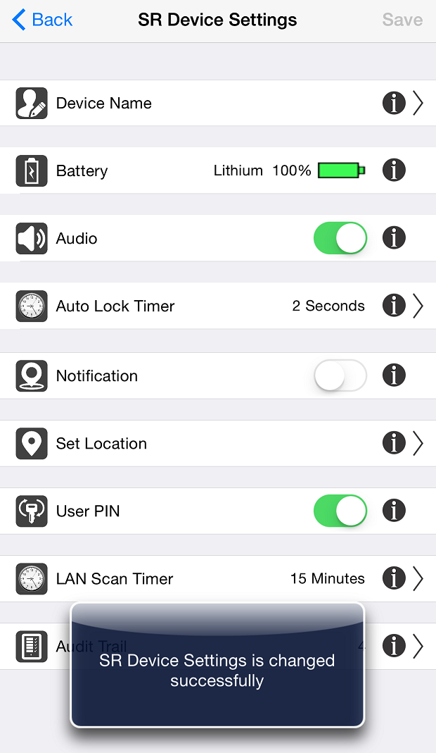

**Figure 49: SR Device Settings**  **Figure 50: SR Device Settings** **Figure 51: Confirmation Message**

**Note:**After change User Pin settings click on “Save” option to change settings.

## LAN Scan Timer

This option allows user to specify the local area network scan interval time. SR Device will stop its scanning within Protocol layer/Master Device after this much of time and will go in sleep mode. This feature will help to increase battery life of your SR device by not doing unnecessary scanning.

1. Click on “LAN Scan Timer” screen from “SR Device Settings”. Refer Figure 52.
2. Choose time “LAN scan time” from given time option. Refer Figure 53.
3. “SR Device Settings is changed successfully” confirmation toast message will display. Refer Figure 54.

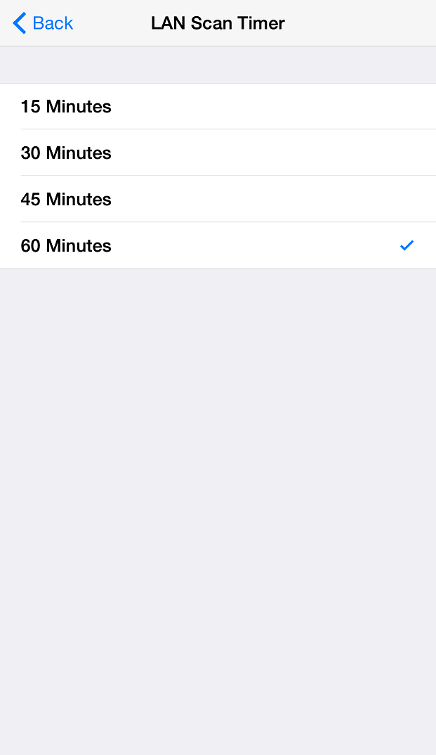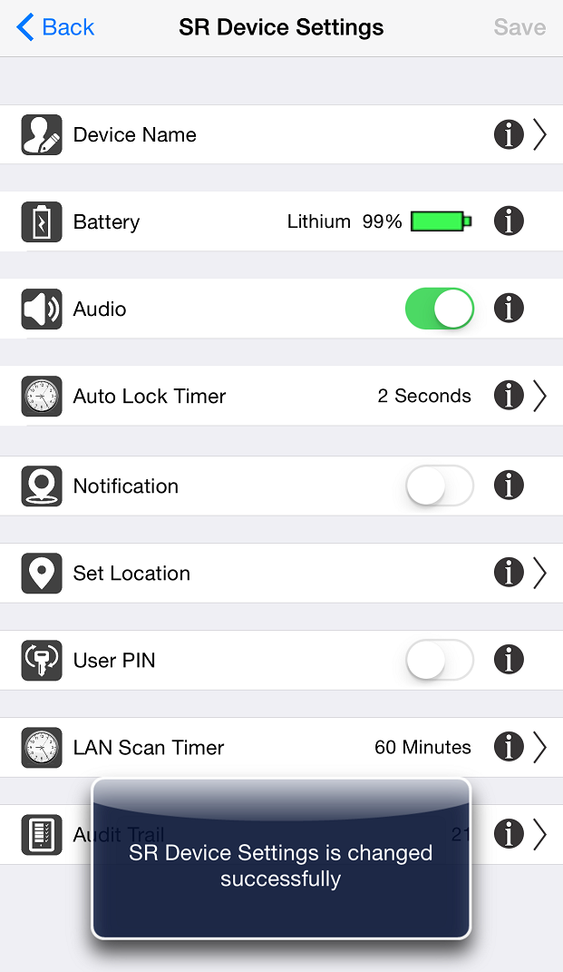

**Figure 52: SR Device Settings** **Figure 53: LAN Scan Timer** **Figure 54: Confirmation Message**

## Audit Trail

This option records and displays the last 255 operations performed.

Each entry has following details:

* Time, Date and Day
* Type
* Status
* User Name

1. Click on “Audit Trail” option from “SR Device Settings”. Refer Figure 55.
2. All the local mode operation will display in “Audit Trail” screen. Refer Figure 56.

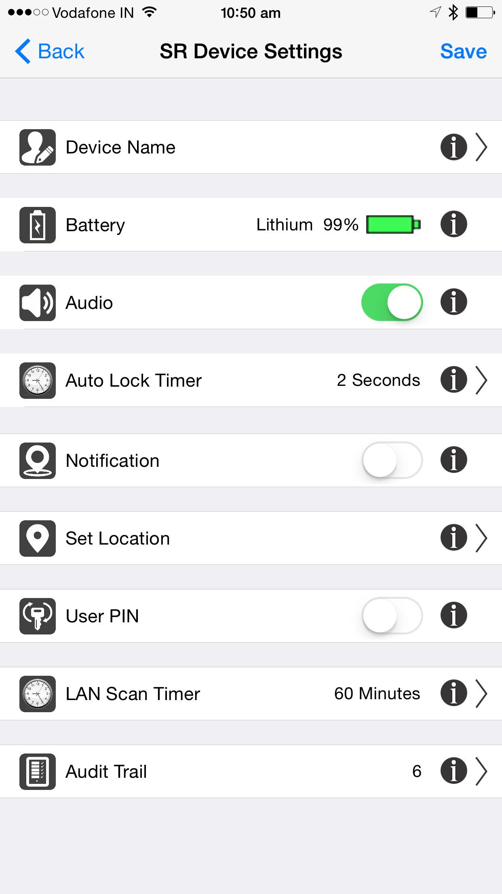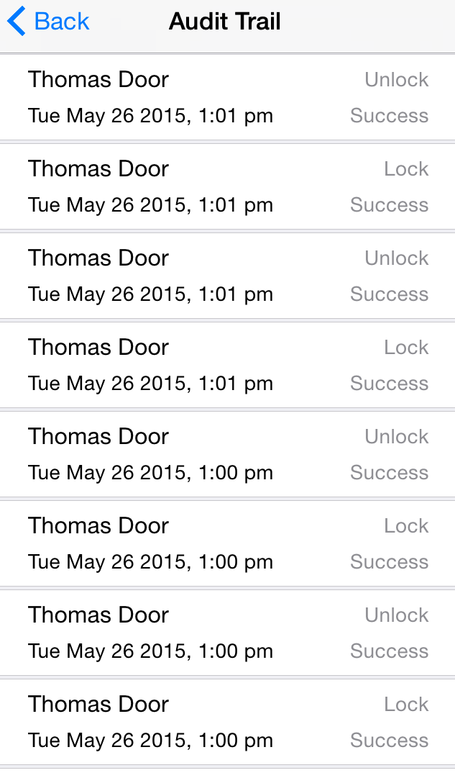

Figure 55: SR Device Settings Figure 56: Audit Trail

*Note:* For operations performed via the Smart Button or Keyfob, the Time, Date and Day will not be available. “Keyfob” will display as User name.

## SR App Settings

This option lets user change the default SR App Settings.

1. Click on “Settings” option from Home screen. Refer Figure 57.
2. It will display “SR KEELER” setting Screen, Click on “SR App Settings” option. Refer Figure 58.
3. It will Display “SR App Settings” screen. Refer Figure 59.

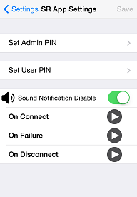

Figure 57: Home Screen Figure 58: Settings Screen Figure 59: SR App Settings

## Set Admin PIN

This option allows the user to change the Admin PIN. Admin PIN must be at least four numeric characters and default value is “1234”.

1. Click on “Set Admin PIN” from SR App Settings screen. Refer Figure 60.
2. It will prompt existing “Admin PIN”; enter default “1234” as admin PIN. Refer Figure 61.
3. Admin PIN screen display. Refer Figure 62.

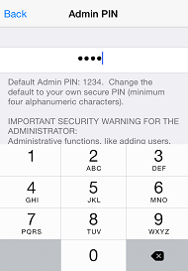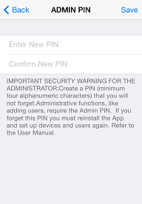

Figure 60: SR App Settings Figure 61: Admin PIN Figure 62: Admin PIN

1. Enter “New Admin PIN”, “Confirm PIN” and click on “Save” button. Refer Figure 63.
2. It will display “Admin PIN changed successfully” message. Refer Figure 64.

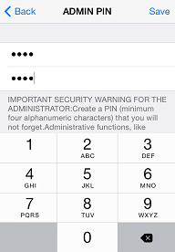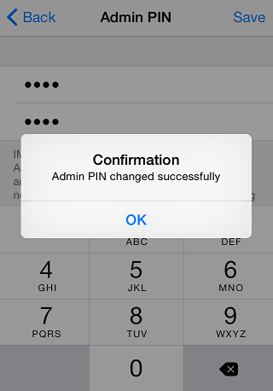

Figure 63: Admin PIN Figure 64: Success Message

*Note:* In order to change Admin PIN, user must know current Admin PIN. Default Admin PIN is “1234”. Admin Pin is stored to smartphone so each user with Admin privilege can set any four alphanumeric characters as Admin PIN. If the user forgets the Admin PIN, user needs to re-install the SR Smart® application.

## Set User PIN

This option allows the user to change the User PIN. The User PIN is a minimum of four alphanumeric characters and provides additional security. The Admin can force new users to use the User PIN. If enabled, the User PIN must be entered every time this user initiates the unlock operation. Only Admin can disable User PIN for any user.

1. Click on “Set User PIN” from SR App Settings screen. Refer Figure 65.
2. It will prompt existing “User PIN”; enter default “1234” as User PIN. Refer Figure 66.
3. User PIN screen will display. Refer Figure 67

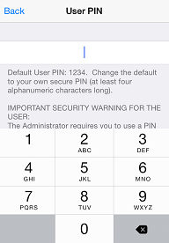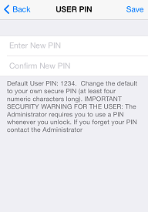

Figure 65: SR App Settings Figure 66: USER PIN Figure 67: USER PIN

1. Enter “New PIN”, “Confirm New PIN” and click on “Save” button. Refer Figure 68
2. It will display “User PIN changed successfully” message. Refer Figure 69

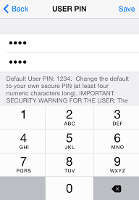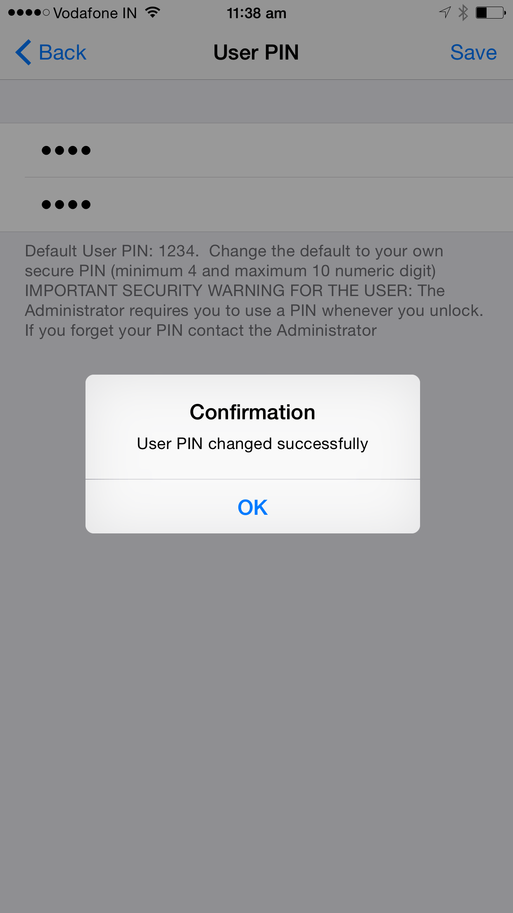

Figure 68: USER PIN Figure 69: Success Message

*Note:* In order to change User PIN, user must know current User PIN. Default User Pin is “1234”. User PIN is stored to smartphone so each user can set any User PIN. If the user forgets the User Pin, user needs to reinstall the SecuRemote® BLE application.

## Sound Notification

The SR App plays different sounds upon Connecting, Disconnecting and any failure event. User can enable/disable this setting.

1. Click on toggle button to disable Sound Notification. Refer Figure 70.
2. Sound Notification is disabled and click on “SAVE” option. Refer Figure 71.
3. “Sound notification settings is changed successfully” toast message will display. Refer Figure 72.

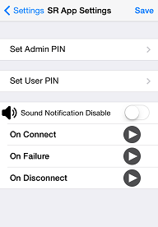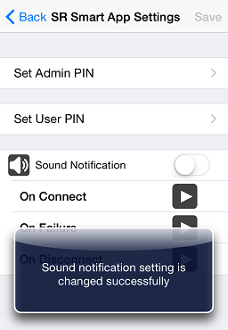

Figure 70: SR App Settings  Figure 71: SR App Settings Figure 72: Success Message

## About SR Device

It provides details on Manufacturer’s Name, Model Number, Hardware Version and Software Version of the SR KEELER.

1. Click on “Settings” from Home screen and click on “About SR Device”. Refer Figure 73.
2. It will open “About SR Device” Screen with SR KEELER details. Refer Figure 74.

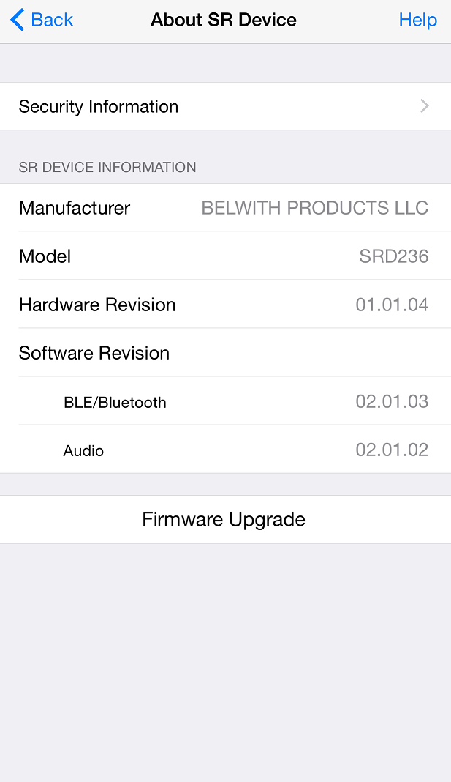

Figure 73: Settings Screen  Figure 74: About SR Device

## Firmware Upgrade

Using this feature user can upgrade Firmware from SR App over the Air (OTA).

1. Click on “Settings” from Home screen and click on “About SR Device” option. Refer Figure 75.
2. It will display “Admin PIN” Screen, enter “Admin PIN”. Refer Figure 76.
3. It will display “Please select firmware file from mail having .bin (For iOS) or .hex(For Android) extension and then select open with SR Smart application option“ message with “ok” button. Refer Figure 77.

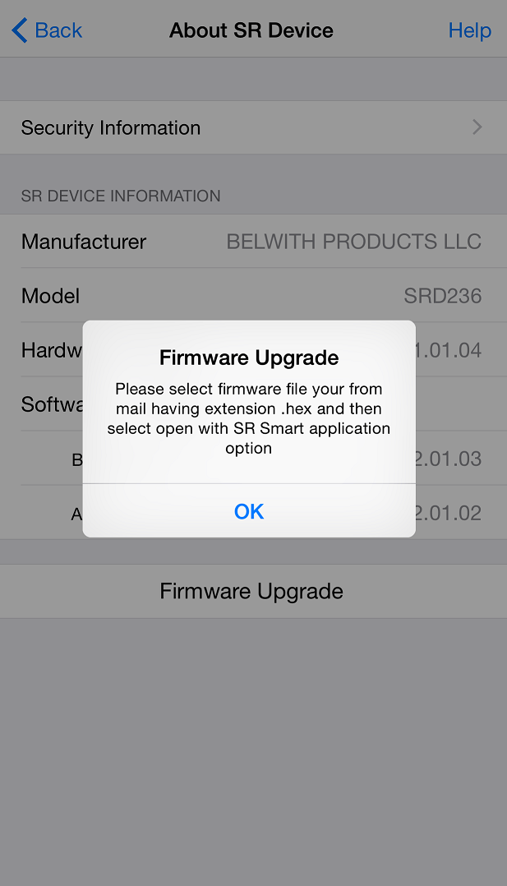

Figure 75: About SR Device Screen Figure 76: Admin PIN Figure 77: Firmware Upgrade Message

1. Open email and click on “.HEX” file to select application. Refer Figure 78.
2. Select “Open in SR Smart®” to open firmware upload screen. Refer Figure 79.
3. Press “Upload Firmware” to start uploading firmware. Refer Figure 80.

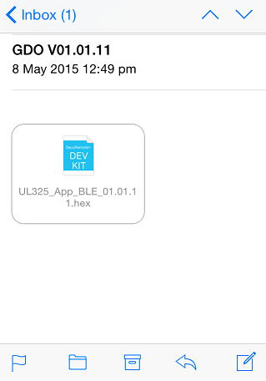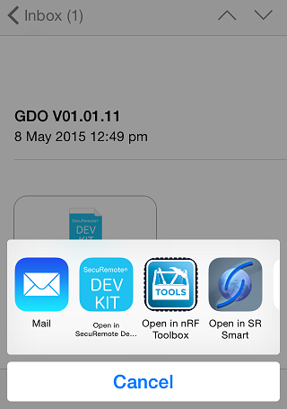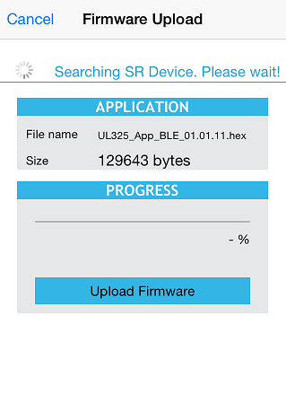

Figure 78: Mail Inbox Figure 79: Select App  Figure 80: Firmware Upload Screen

1. Wait for Complete 100% progress bar. Refer Figure 81.
2. Firmware “Finished upload” message will be displayed with “OK” button. Refer Figure 82.

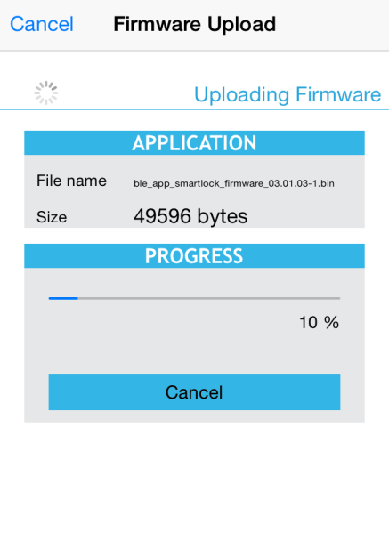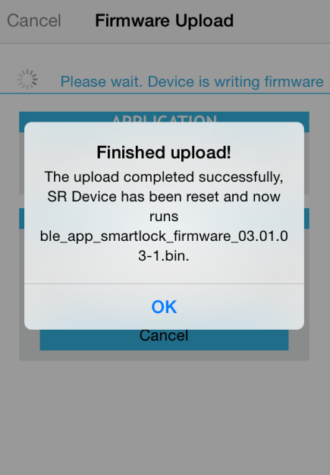

Figure 81: Uploading Firmware Figure 82: Finished Uploaded Message

# Device Management

The user can click on “Devices” option from SR Smart App Home Screen to display, add, delete, rename or check status of all installed SR KEELER controlled by this iOS/Android device.

## Add Device

To add new SR device user can use this option.

1. Select Devices option from Home Screen. Refer Figure 83.
2. Click on Add SR Device to add new device. Refer Figure 84.
3. In Add SR Device user can add device using available options. Refer Figure 85.

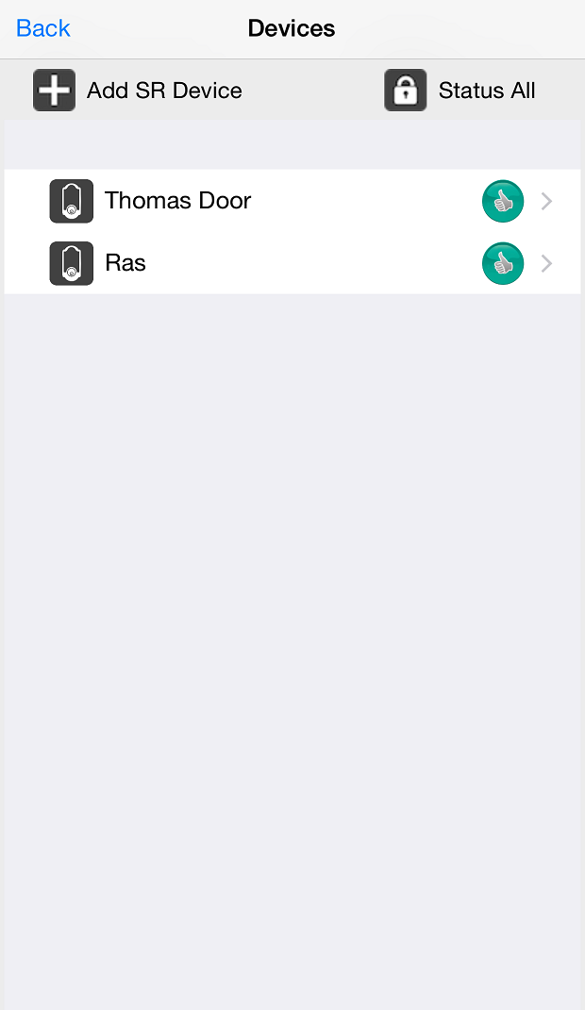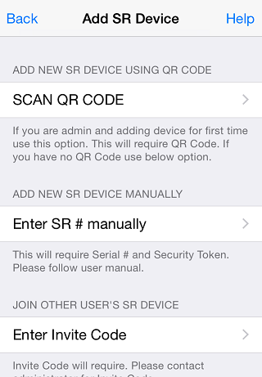

**Figure 83:** **Home Screen** **Figure 84: Device Screen** **Figure 85: Add Device Screen**

## Rename Device

In this option use can change SR Device name.

1. From Home Screen select existing name of the device. Refer Figure 86.
2. It will redirect to SR Device Name screen and provide new name. Refer Figure 87.
3. Click on “Save” button and it will change new name. Refer Figure 88.

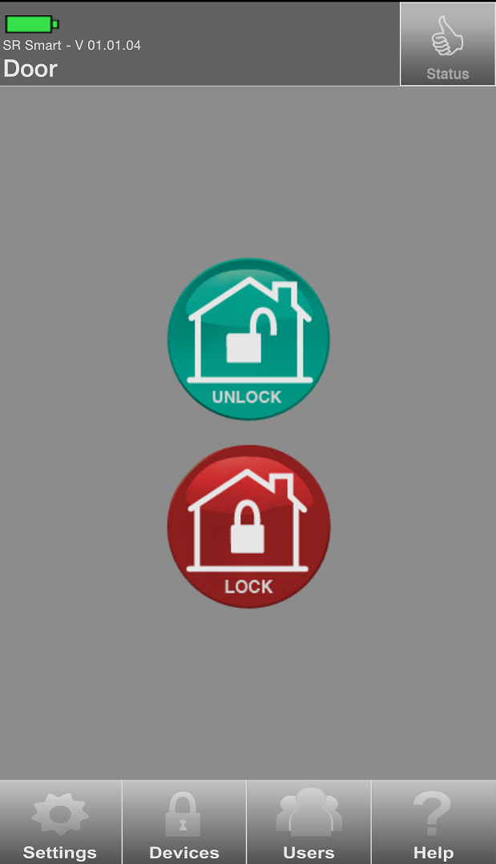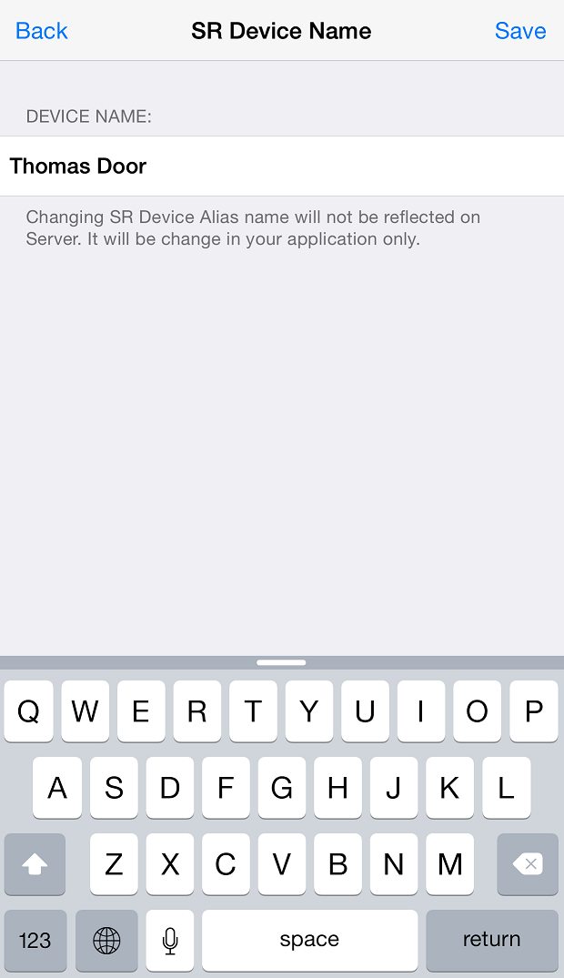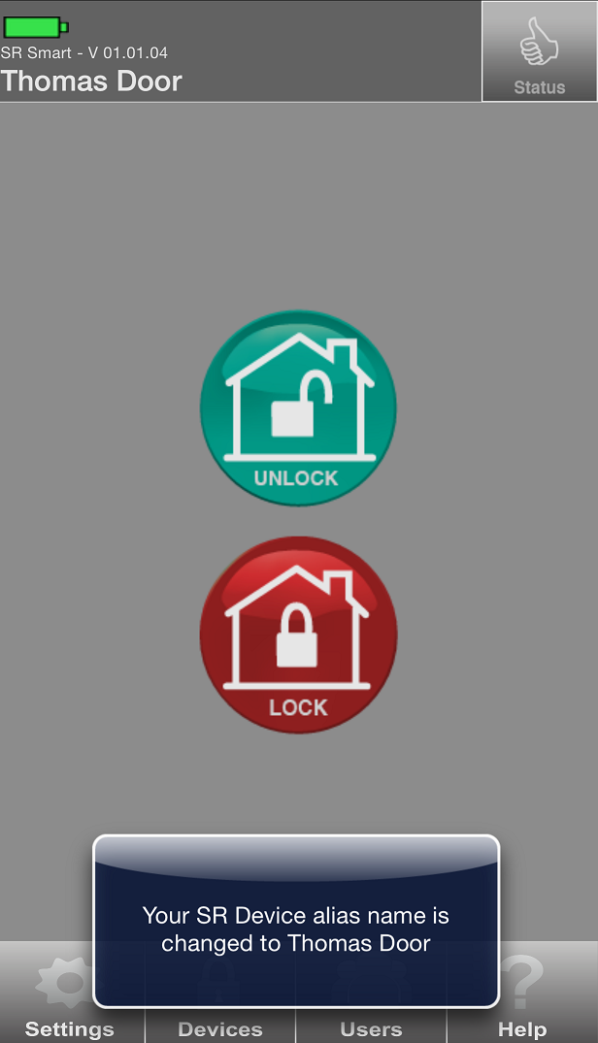

**Figure 86: Home Screen** **Figure 87: SR Device Name Screen** **Figure 88: Name Changed Screen**

## Delete Device

The Admin user only can delete any SR KEELER Device by clicking on “Delete SR Device” option from “Settings” screen. Click on “Delete SR Device” button to delete that device. Confirm the action by clicking on Yes to complete the process:

***Note:*** This option is only available for Admin

1. Click on Settings from home screen. Figure 89.
2. Click on Delete SR Device. Refer Figure 90.
3. It will ask user to enter Administrator Details. Refer Figure 91.

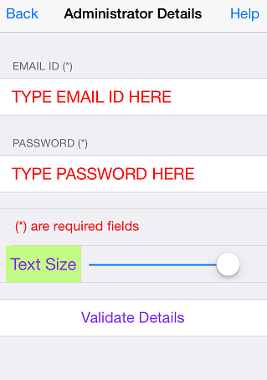

**Figure 89: Home Screen** **Figure 90: Settings Screen** **Figure 91: Administrator Details**

1. Enter Proper Details and click on Validate Details screen. Refer Figure 92.
2. It shows Removing SR Device. Refer Figure 93.
3. After Removing SR Device it will redirect to Add SR Device Screen. Refer Figure 94.

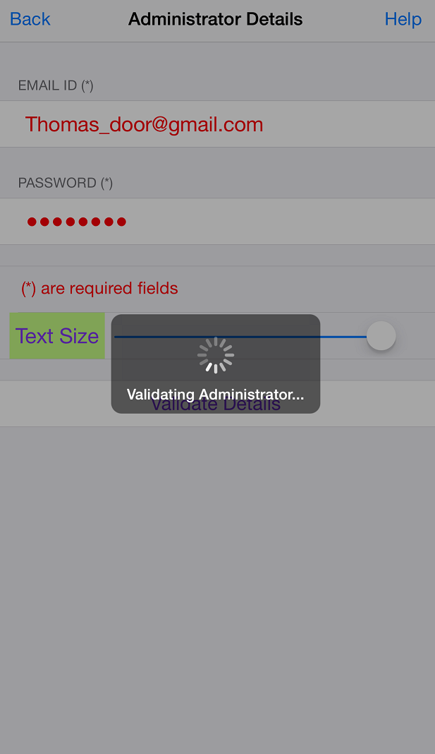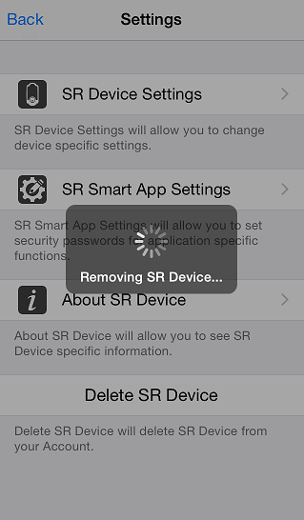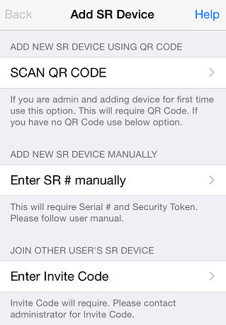

**Figure 92: Administrator Details** **Figure 93: Removing SR Device** **Figure 94: Add SR Device Screen**

## Status All

This option lets user retrieve the current status of all connected SR Devices managed by this application.

1. Click on Devices Screen. Refer Figure 95
2. Click on Status All. Refer Figure 96.
3. It will show status of all devices. Refer Figure 97.

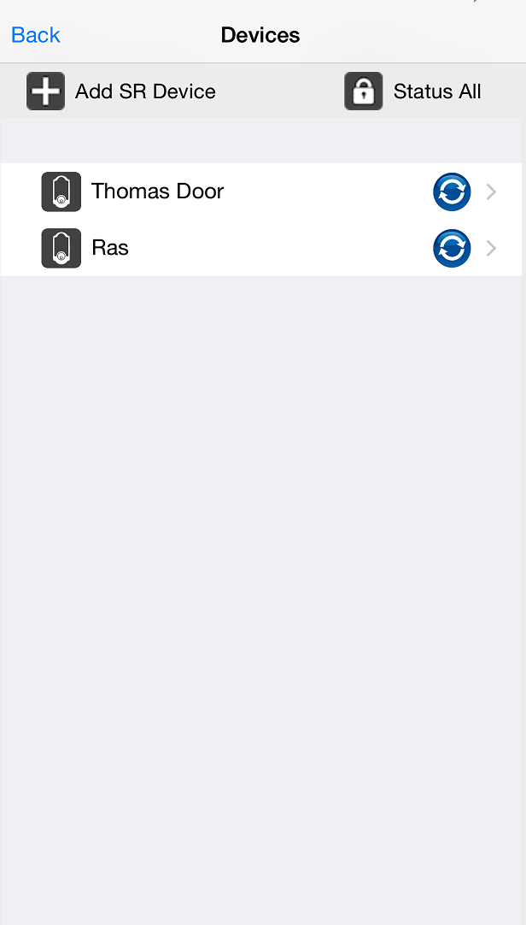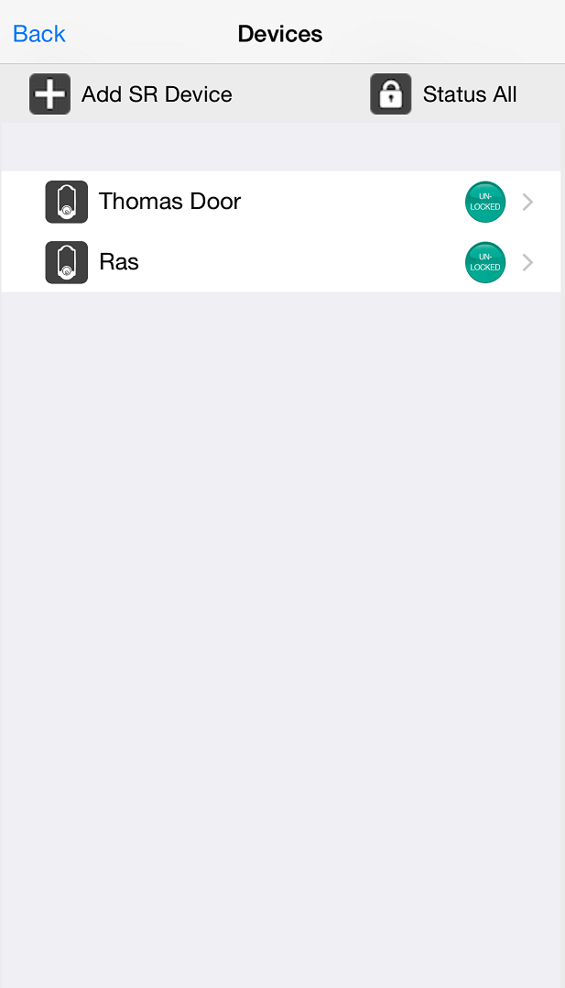

**Figure 95: Devices Screen**  **Figure 96: Devices Screen** **Figure 97: Devices Status Screen**

## 

## Switching between devices

To switch between SR KEELER, the user must go to the “Devices” menu at the bottom of the SecuRemote® App home screen. All managed SR Devices will be displayed, and the user can select the SR Devices they want to operate.

**Example:** The user is added with two SR device “Thomas Door” (Keeler) and “RAS” device. To operate “Thomas Door,” the user selects that name from the listed devices. The selected SR KEELER’s Home screen will appear on the home screen of the SR Smart® app.

1. Click on “Devices” from Home screen. Refer Figure 98 .
2. Select Device from “Devices” screen. Refer Figure 99.
3. It will display selected device in “Home” screen and confirmation message will display. Refer Figure 100.

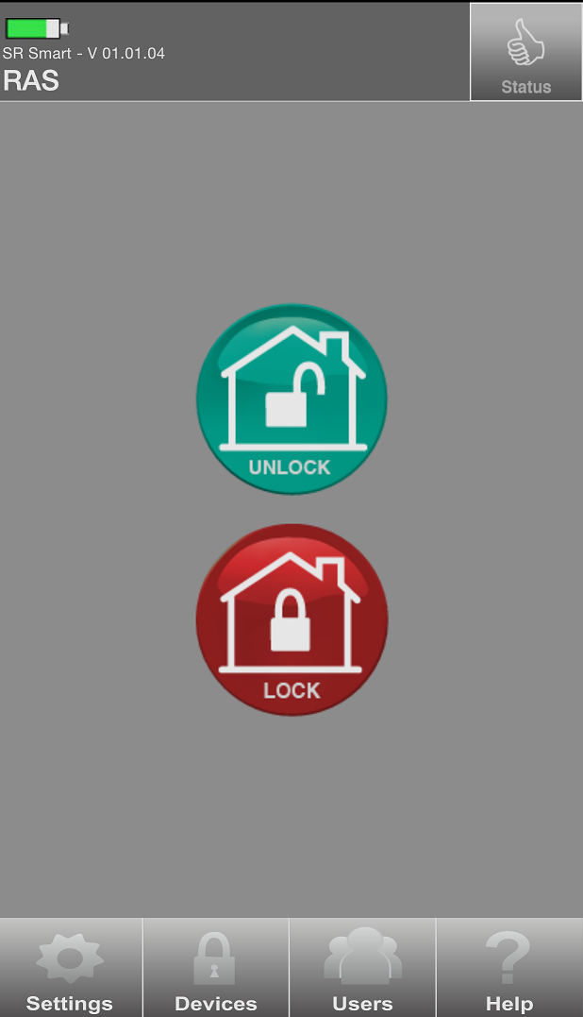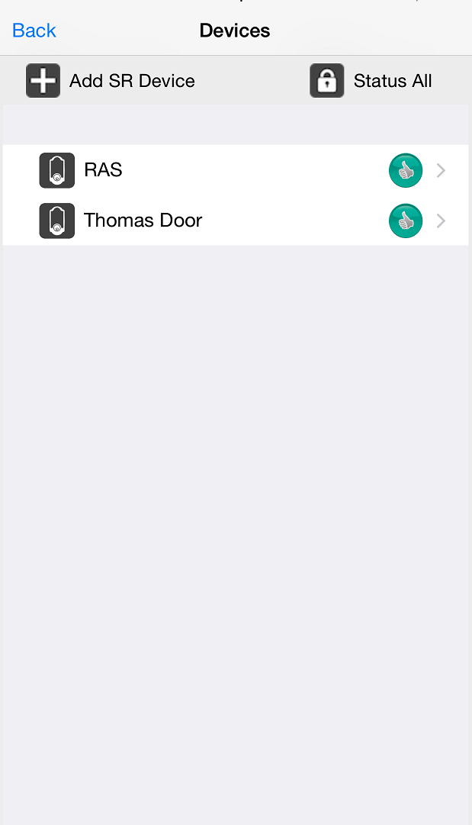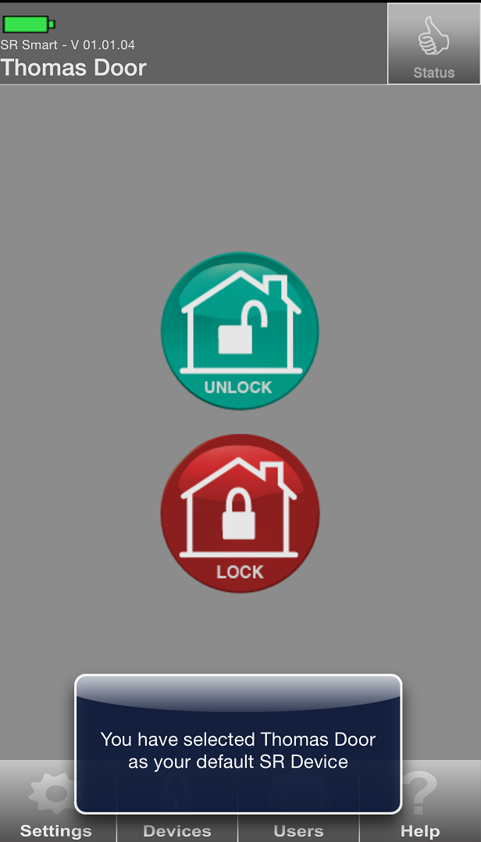

Figure 98: Home Screen Figure 99: Devices Screen Figure 100: Change Home Screen

# Users Management

User List provides the following functionality for each selected user:

* Add/Delete users
* Send SMS and Email to a User

This option allows the admin to invite, delete user. Access to this option is protected through the Admin PIN.

**Once invited, the Admin can share the Invite Code with the new user through: Email or SMS**

|  |  |
| --- | --- |
| Email | This option will sent email with new invite code using email address provided for the new user. The new user then enters this Code and serial number of the SR KEELER when this new user installs and launches the SR Smart BLE Application and tries to pair with the SR KEELER device. |
| SMS | This option will sent SMS with new invite code using phone number provided for the new user. The new user then enters this Code and serial number of the SR KEELER when this new user installs and launches the SR Smart BLE Application and tries to pair with the SR KEELER device. |

## 

## Add User

## Add User from Contact Book

The Admin can invite other users by clicking > ‘Invite User’ on the Users screen. Choose the invitee from the Contacts list, or enter the invitee’s name, email address, and mobile number. Next, choose the access type. Finally, click “Get Invite Code” to generate the invitee’s access code.

1. Click on “Users” from Home Screen. Refer Figure 101.
2. It will prompt for “Admin PIN”. Refer Figure 102.
3. Enter admin PIN to display “Access Devices” screen. Refer Figure 103.

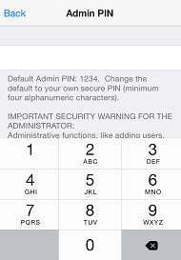

Figure 101: Home Screen Figure 102: Admin PIN Screen  Figure 103: Input Admin PIN

1. It will display “Access Devices” Screen with “Invite User” and “Add Keyfob” options. Click on “Invite User”. Refer Figure 104.
2. It will display “Administrator Details” Screen for user validation. Refer Figure 105.
3. Enter Administrator “EMAIL ID” and “PASSWORD” and click on “Validate Details”. Refer Figure 106.

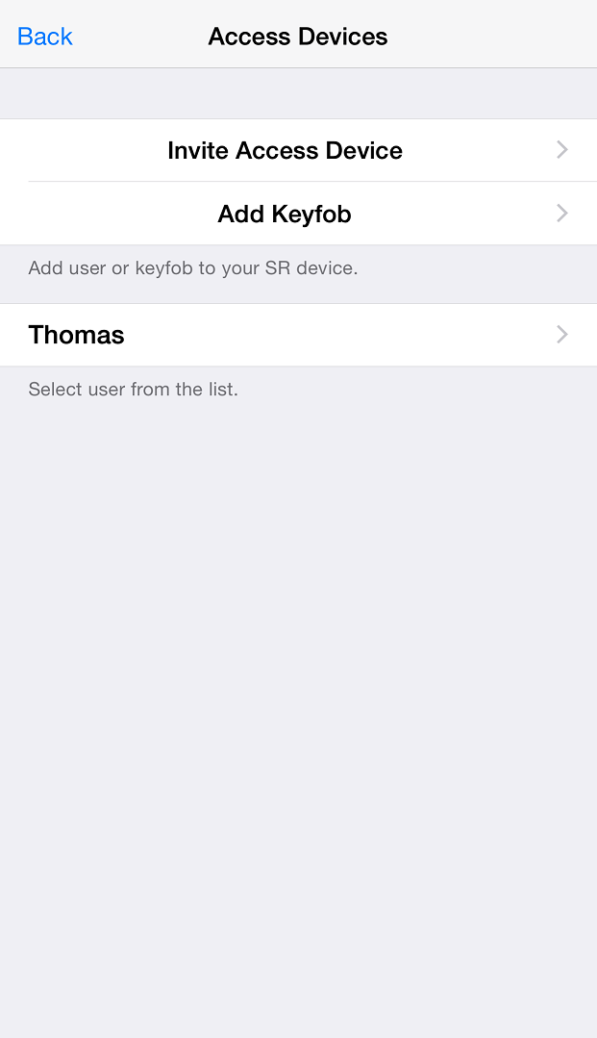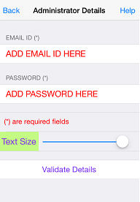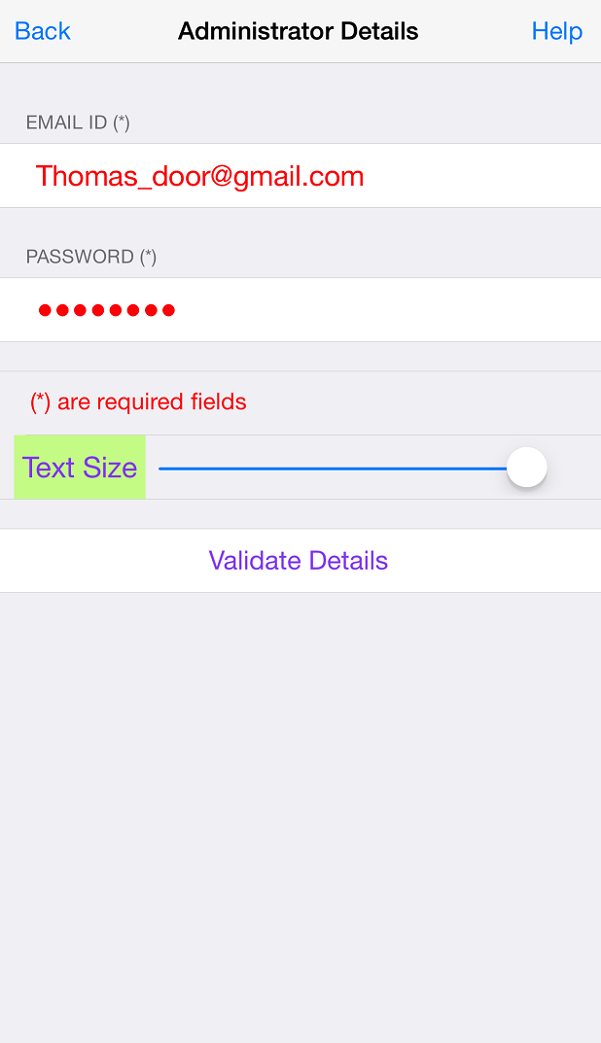

Figure 104: Access Devices Screen Figure 105: Admin Validation Screen Figure 106: Admin Validation Screen

1. It will display “Validating Administrator” activity message. Refer Figure 107.
2. It will display “Invite Users” screen with an option to select from Contacts and Field to enter user name. It also displays options to send User alert via email or SMS for the selected user. Click on “Select from contacts”. Refer Figure 108.
3. Phone Contact list will appear. Select any contact from phone book. Refer Figure 109.

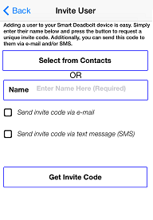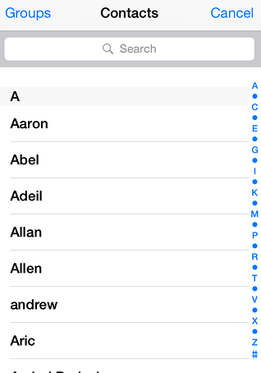

Figure 107: Admin Validate Message Figure 108: Phone contact Book Figure 109: Invite User Screen

1. It will display selected contact from the contact list. Click on contact number. Refer Figure 110.
2. It will display “Invite User” screen with option to send User alert via email or SMS. Refer User Detail Figure 111
3. Click on Check boxes and fill mandatory information then click on “Get Invite Code”. Refer Figure 112.

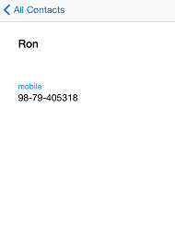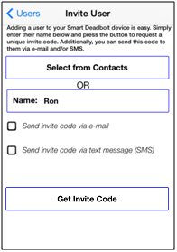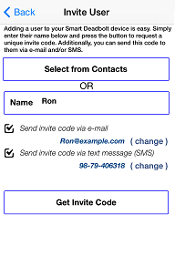

Figure 110: User Detail Figure 111: Invite User Screen Figure 112: Invite User Screen

1. It will display “Inviting User” activity message. Refer Figure 113.
2. Invite code is generated with a display message to “Notify User” through the chosen mode with “YES” and “NO” option. Select desired option. Refer Figure 114 .
3. It will display added user name in “Access Devices” screen. Refer Figure 115.

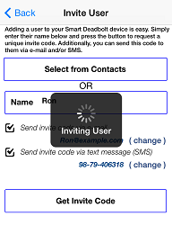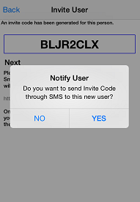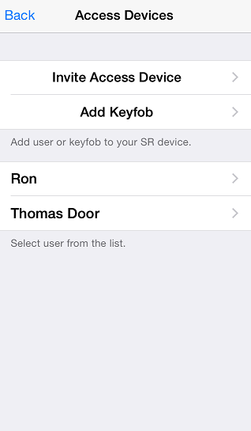

Figure 113: Inviting User Message Figure 114: Notify User Figure 115: Changed picture

***Note:*** To add a user using phone’s contact list, click on ‘Select from Contacts’. The new user’s details will automatically appear, and the Admin can just click on ‘Get Invite Code’ to add that user to the users list.

## Add User Manually

1. Click on “Users” from Home Screen. Refer Figure 116.
2. It will prompt for “Admin PIN”. Refer Figure 117.
3. Enter admin PIN to display “Access Devices” screen. Refer Figure 118



Figure 116: Home Screen Figure 117: Admin PIN Screen Figure 118: Input Admin PIN

1. It will display “Access Devices” Screen with “Invite User” and “Add Keyfob” options. Refer Figure 119.
2. It will display “Administrator Details” Screen for user validation. Refer Figure 120.
3. Enter Administrator “EMAIL ID” and “PASSWORD” and click on “Validate Details”. Refer Figure 121.

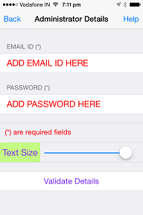

Figure 119: Users Screen Figure 120: Admin Validation Screen Figure 121: Admin Validation Screen

1. It will display “Validating Administrator” activity message. . Refer Figure 122.
2. It will display “Invite Users” screen. . Refer Figure 123.
3. Enter user name in “Name” Field, and select option to send User alert via email or SMS. . It will also display Authorization setting for the selected user. Refer Figure 124.

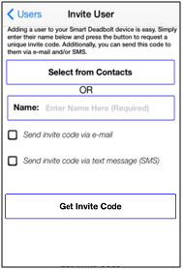

Figure 122: Admin Validate Message Figure 123: Invite user Screen Figure 124: Invite User Screen

1. Click on Check boxes and fill mandatory information then click on “Get Invite Code”. Refer Figure 125.
2. It will display “Inviting User” activity message. Refer Figure 126.
3. Invite code is generated with a display message to “Notify User” through the chosen mode with “YES” and “NO” option. Select on desired option. Refer Figure 127.



Figure 125: Invite User Screen  Figure 126: Inviting User Message Figure 127: Notify User Message

1. It will display added user name in “Access Devices” screen. Refer Figure 128



Figure 128: Access Device

## About Access Device

User can view list of all user and detail in “About Access Device” screen.

1. From “Access Device” screen click on “Ron“. Refer Figure 129.
2. It will display “Access Device” screen, Click on “About Access Device” option. Refer Figure 130.
3. It will display “About Device” with user’s Smartphone details. Refer Figure 131.

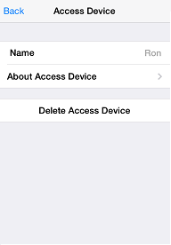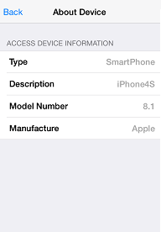

Figure 129: Access Device Screen Figure 130: Access Device Screen Figure 131: About Device Screen

## Delete Access Device

1. From “Access Device Screen” screen click on “User name (RON) “. Refer Figure 132.
2. It will display “Access Device” screen with all the user options, click on “Delete Access Device”. Refer Figure 133.
3. It will display “Removing User” message with “Yes” and “No” button and Click on “Yes”. Click on “Yes”. Refer Figure 134.

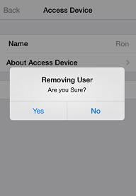

Figure 132: Access Device Screen Figure 133: Admin Screen Figure 134: Removing User

1. It will display “Removing User” activity message. Refer Figure 135.
2. It will display “Access Device “screen with list of current access devices. Refer Figure 136.

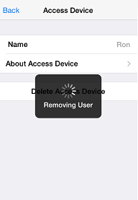

Figure 135: Removing User Message Figure 136: Access Device Screen

***Note:*** Admin User cannot delete itself.

## Keyfob

It allows the addition of a Keyfob as another user so it can operate the SR KEELER, a SR KEELER package may include one or more Keyfob. One Keyfob device can operate up to 4 Locks (SR KEELER).

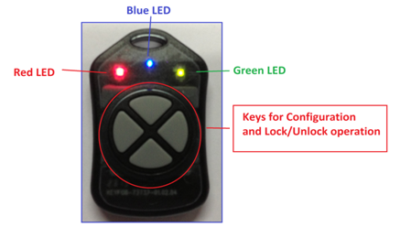

The Keyfob must be configured before it can be added as a user. To configure a Keyfob, the Smart phone and the Keyfob must be within radius of 20 feet from the Lock.

## Add Keyfob

1. Click on “Users” from Home Screen. Refer Figure 137.
2. It will prompt for “Admin PIN”. Refer Figure 138.
3. Enter admin PIN to display “Access Devices” screen. Refer Figure 139.



Figure 137: Home Screen Figure 138: Admin PIN Screen  Figure 139: Input Admin PIN

1. It will display “Access Devices” Screen with “Invite User” and “Add Keyfob” options. Click on “Invite Access Device”. Refer Figure 140.
2. It will display “Administrator Details” Screen for user validation. Refer Figure 141.
3. Enter Administrator “EMAIL ID” and “PASSWORD” and click on “Validate Details”. Refer Figure 142.



Figure 140: Users Screen Figure 141: Admin Validation Screen Figure 142: Admin Validation Screen

1. It will display “Validating Administrator” activity message. Figure 143.
2. It will prompt “Add Keyfob message” with “OK” button, click on “OK” button. Refer Figure 144.
3. It will display “searching for Keyfob” message along with “Red” and “Green” LED indication, Press and hold any Keyfob button for 5 seconds to configure Keyfob. Refer Figure 145.

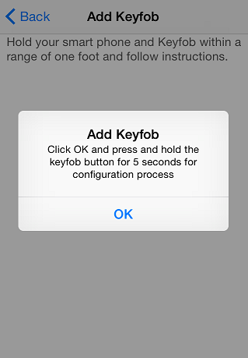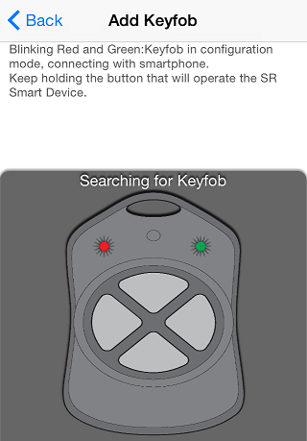

Figure 143: Admin Validate Message  Figure 144: Add Keyfob Figure 145: Searching Keyfob

1. When Keyfob is detected the SR KEELER it will display a message “Configuring Keyfob, please wait” with “Blue LED” indication. Refer Figure 146.
2. Once configured, it will display “Keyfob button is configured” toast message. Refer fob Configuring Figure 147.
3. It will display a message “Keyfob activated to work with this SR KEELER by pressing the button: Connecting - Blue LED, Unlocking – GREEN LED for 3 sec, Locking - RED LED for 3 seconds” with “OK” button. Refer Figure 148.

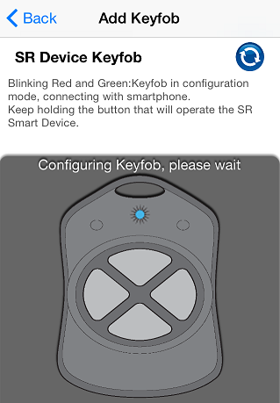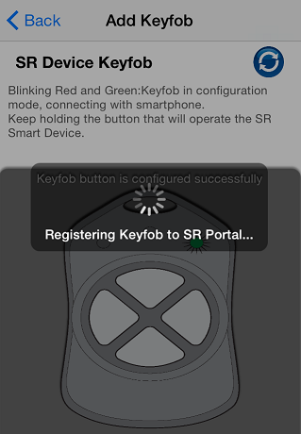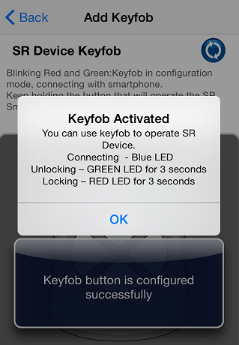

Figure 146: Keyfob Configuring Figure 147: Keyfob configured Figure 148: Keyfob button activated

## About Keyfob Device

1. From “Access Devices” screen click on “KEYFOB-96235634“. Refer Figure 149.
2. It will display “Access Device” screen, Click on “About Access Device” option. Refer Figure 150.
3. It will display “About Device” with Keyfob’s details. Refer Figure 151.

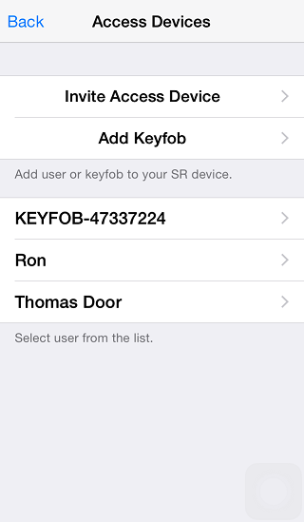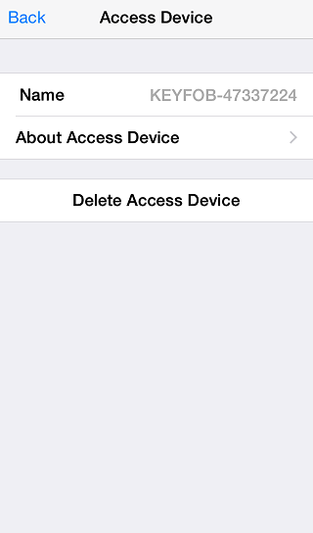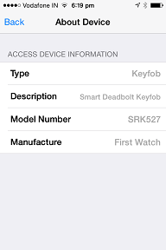

Figure 149: Access Devices Screen Figure 150: Access Device screen Figure 151: About Device Screen

## Delete Keyfob Device

1. From “Access Devices” screen click on “KEYFOB”. Refer Figure 152.
2. It will display “Access Device” screen with all the user options, click on “Delete Access Device”. Refer Figure 153.
3. It will display “Removing User” message with “Yes” and “No” button and Click on “Yes”. Refer Figure 154.

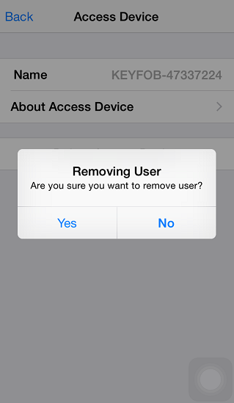

Figure 152: Access Device Screen Figure 153: Access Device screen  Figure 154: Removing User screen

1. It will display “Removing User” activity message. Refer Figure 155.
2. After that it will redirect to the “Access Devices” screen with current access device list. Refer Figure 156.

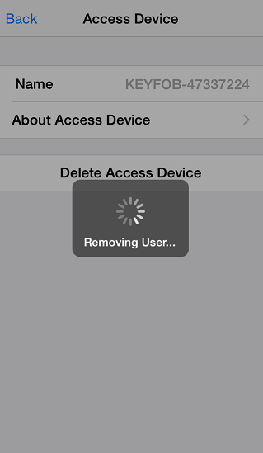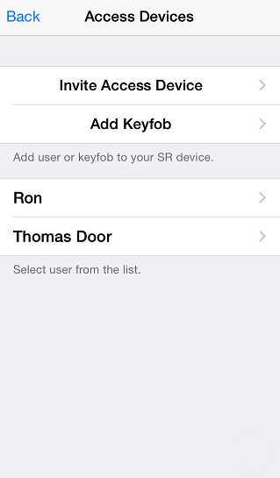

Figure 155: Removing User Message  Figure 156: Access Devices Screen

# Help Option

In this option user can view “HELP” file and from developer option user can enable “Camera”:

* Help
* Developer Options

## Help

When user click on “Help” option it shows help file to the user.

1. Click on “Help” option from home screen. Refer Figure 157.
2. Click on “Help” from “Information” Screen Refer Figure 158.
3. It shows “Help” file. Refer Figure 159.

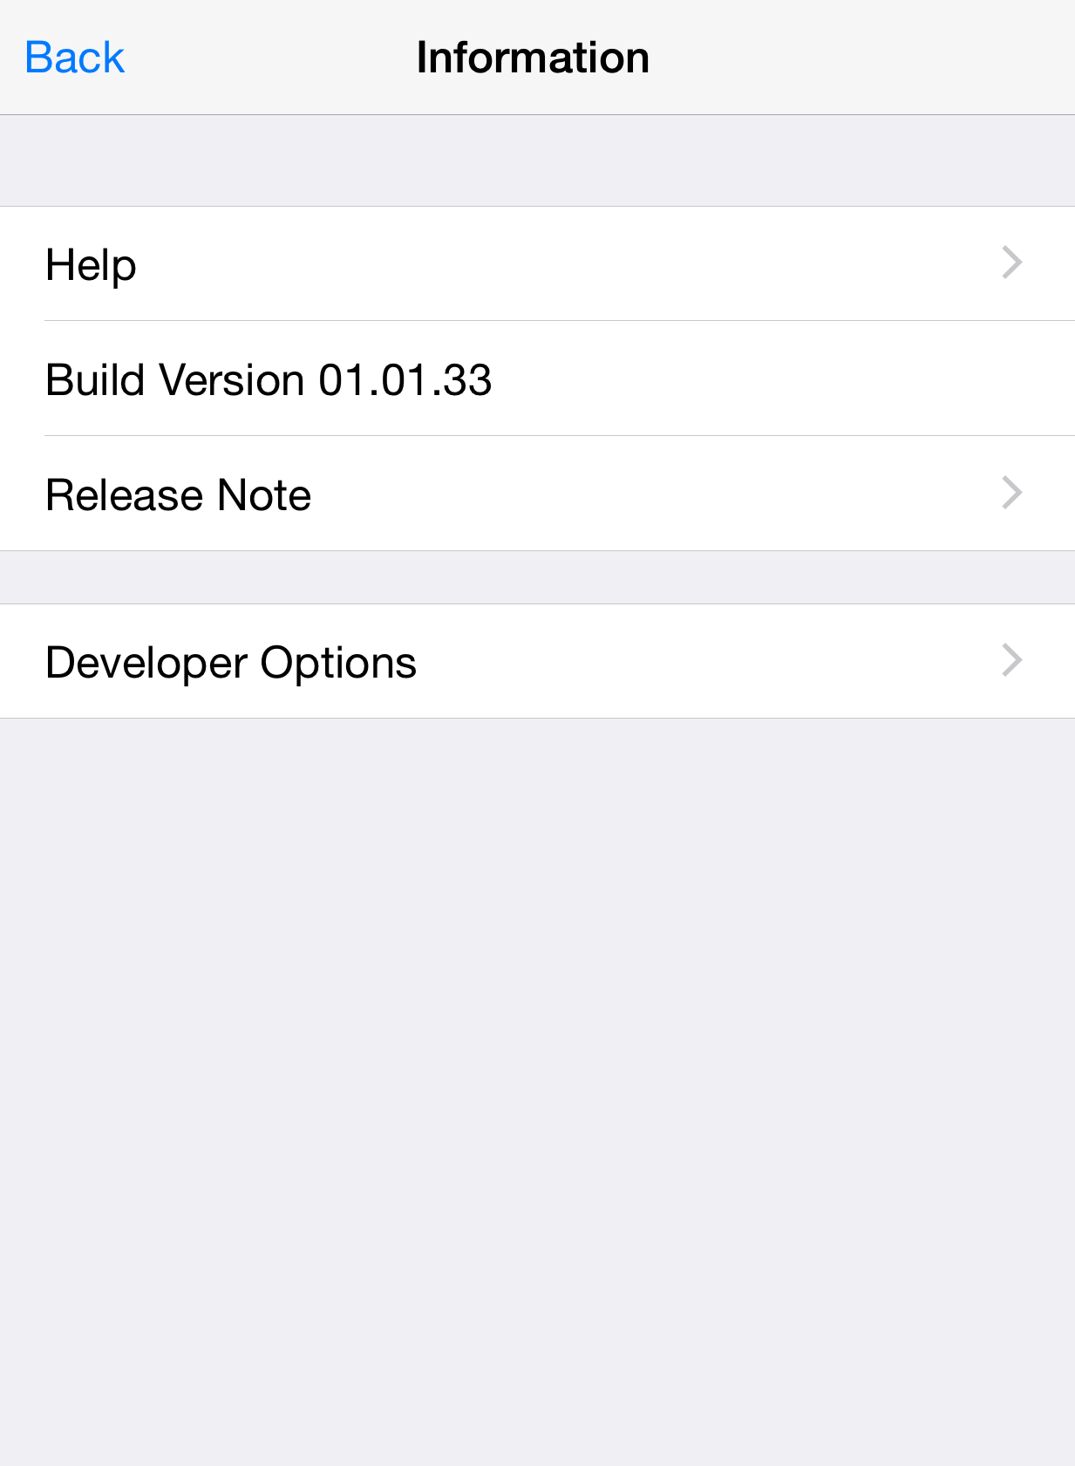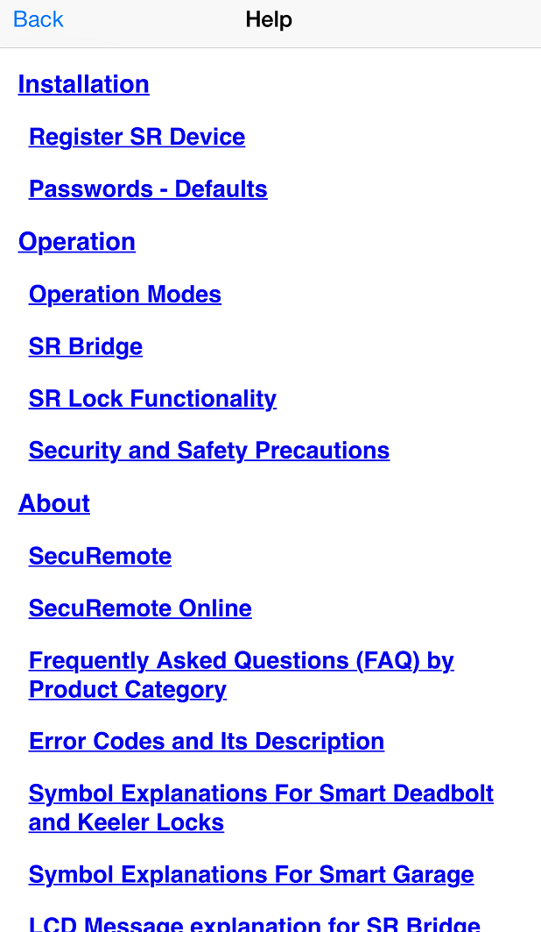

**Figure 157: Home Screen** **Figure 158: Information Screen** **Figure 159: Help Screen**

## Developer Options

## Camera Settings

**IP Camera support**

**Camera Type**

1. **D-Link: Following camera models are supported:**

* DCS-942L
* DCS-930L
* DCS-933L

1. **Foscam: Following camera models are supported:**

* FI8910W
* FI8918W

**Set up IP camera**

**Following Information will be required to Set Camera IP**

* Camera Type.
* Select camera model
* Enter external (WAN) IP address (Host)
* Enter port number
* Enter User name
* Enter Password

**External (WAN) IP address**

From PC or Phone which is connected to same router to which IP camera is connected, open browser and type.

**Steps to Enable IP camera**

1. Click on “Help” option to open “Help” screen. Refer Figure 160 .
2. Click on “Developer Options” and it will prompt for “Developer PIN”. Refer Figure 161.
3. Enter default PIN “123456” as Developer PIN. Refer Figure 162.

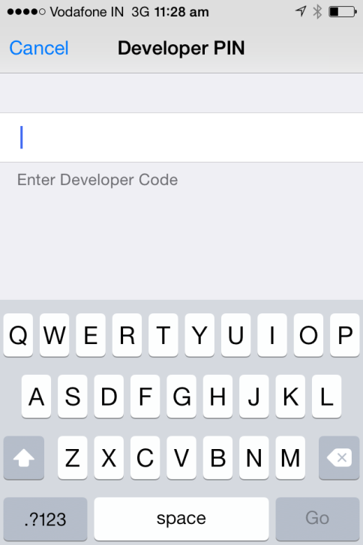

Figure 160: SR app Home Screen Figure 161: Help Screen Figure 162: Developer PIN Input Screen

1. It will display “Developer Options” screen, click on “Camera Settings”. Refer Figure 163.
2. Enable “Camera”, fill all mandatory information, “Save” the settings & return to the Home Screen.

Refer Figure 164.

1. Camera picture will display in “SR App Home Screen”. Refer Figure 165.

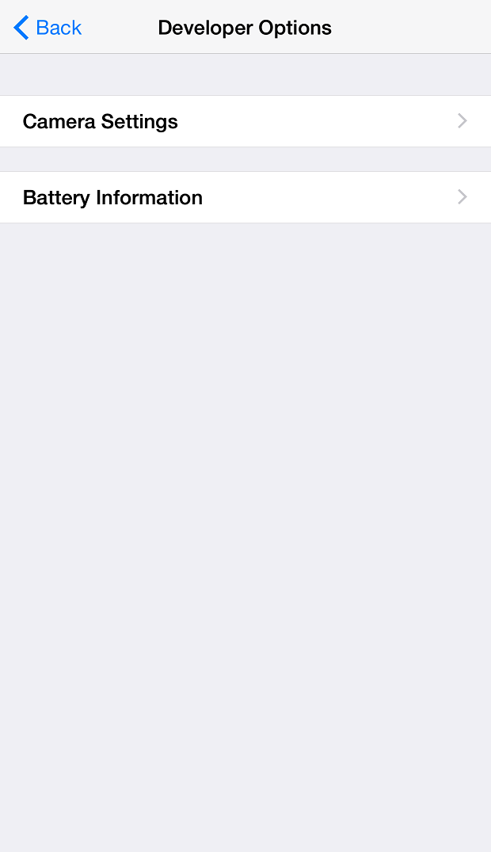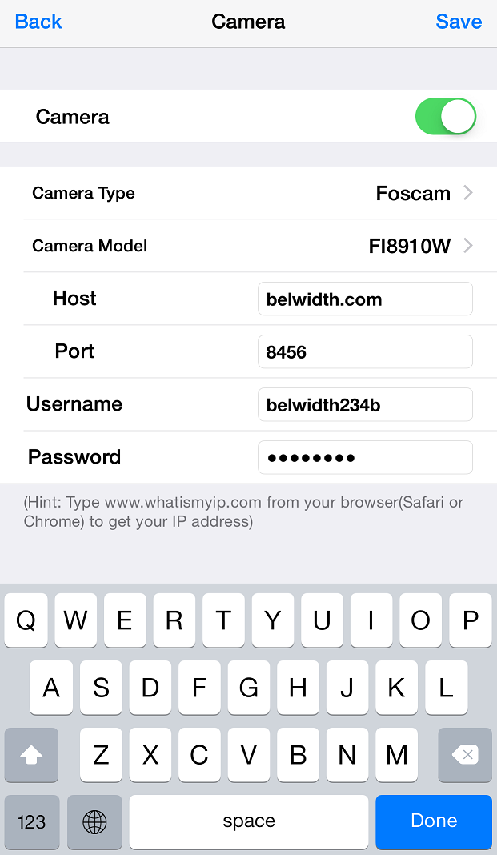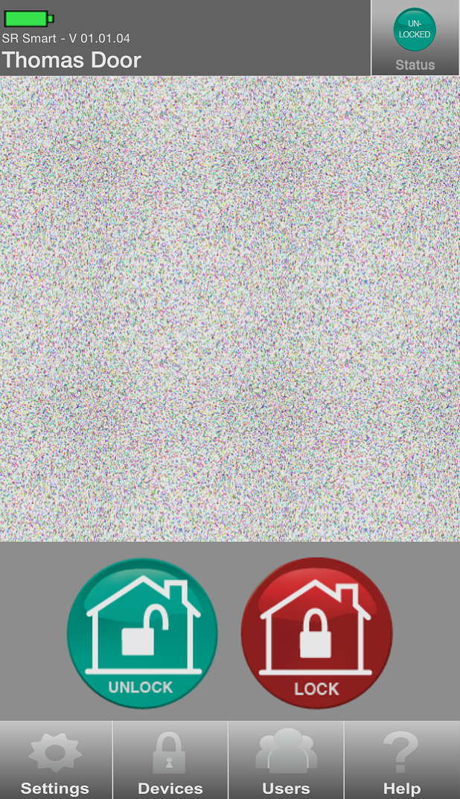

Figure 163: Developer Options Screen Figure 164: Camera User Input  Figure 165: SR App Home Screen

## Battery Information

This option allows user to check detail usage of battery which includes following options.

* Type of Power supply (Alkaline, Lithium and Mains)
* Total Hours
* Remaining Hours
* Operation Done

1. Click on “Battery Information” option from “Developer Option” screen. Refer Figure 166
2. “Updating Battery Information” activity screen will display. Refer Figure 167
3. Detail battery information will display in “Battery Information” screen. Refer Figure 168

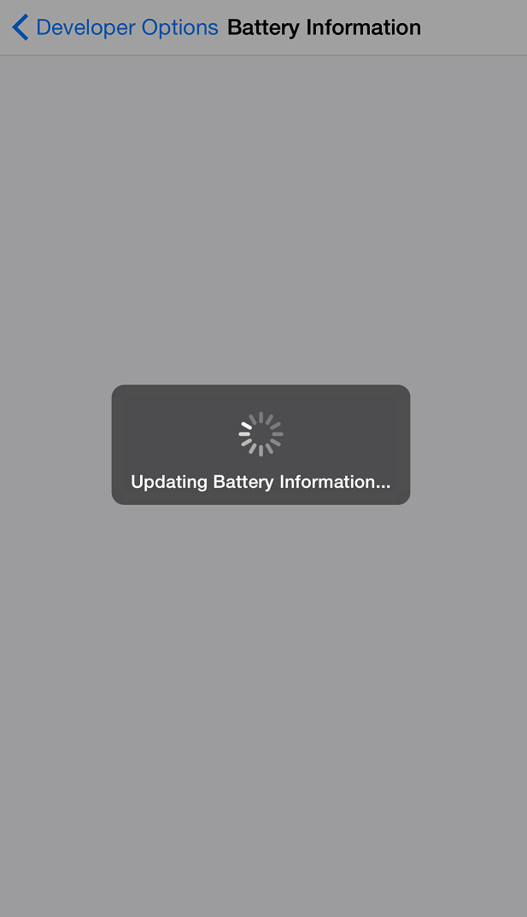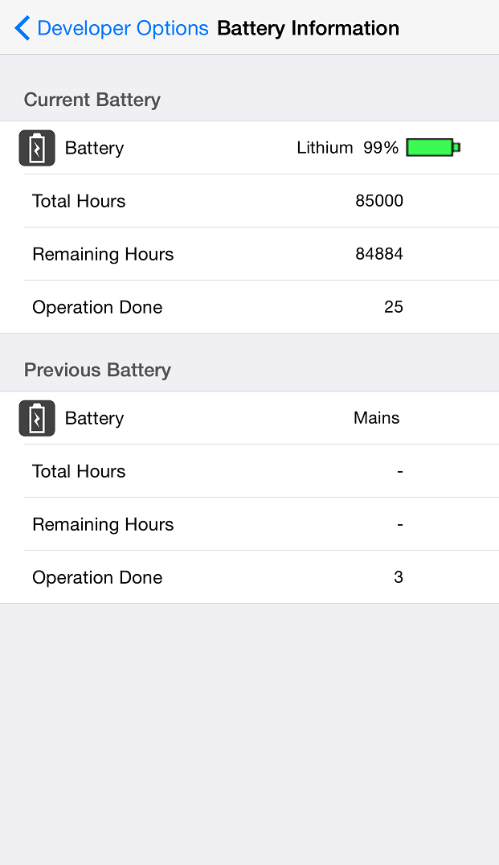

Figure 166: Developer Options Screen Figure 167: Updating Screen Figure 168: Battery Information

# SR Portal

SecuRemote® Online allows users to expand the capabilities of SecuRemote Smart™. This web-based user management and authorization system lets the SecuRemote Smart™ Administrator use a computer to remotely manage users and their access times/days, and to monitor door use. SecuRemote® Online brings more convenience, control and security to families.

## Sign up for SR Portal

Go to [http://portal.securemote.com](http://portal.securemote.com/) and click on the “Create New Account” button to begin SecuRemote® Online. Refer Figure 169.

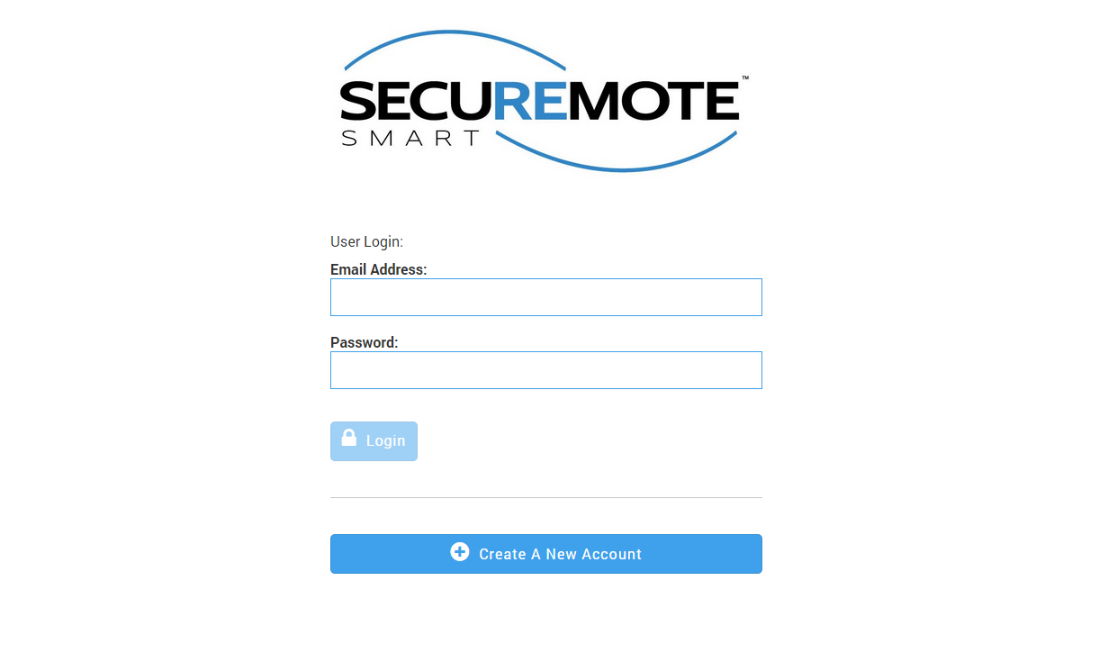

Figure 169: Sign Up

## New Customer Registration

The “New Customer Registration” screen appears. This screen collects basic login information about you and your SecuRemote Smart™ device as follows. Refer Figure 170.

* The E-mail address you enter is the username you will use to log-in again
* Passwords must be at least 6 characters long. There is no requirement for password complexity.
* Registration requires an “Email Address”, “Account Name” and “Password”. This information is stored for the account.
* Since devices may be installed in different geographical areas, it is important to know which time zone each device is in. This way schedules can be specified in local time for each device.

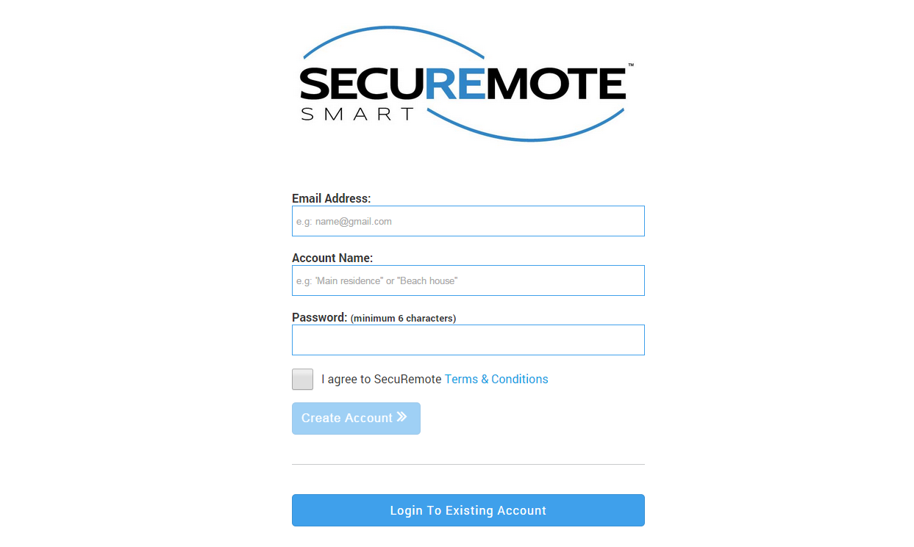

Figure 170: New Customer Registration

## Activate Your Account

Upon successful registration, the following screen appears and an e-mail entitled “Action required to activate your SecuRemote® Online service” is sent to you, with further instructions. Click (or copy and paste) on the link provided in the e-mail to verify ownership of the e-mail address. Refer Figure 171.

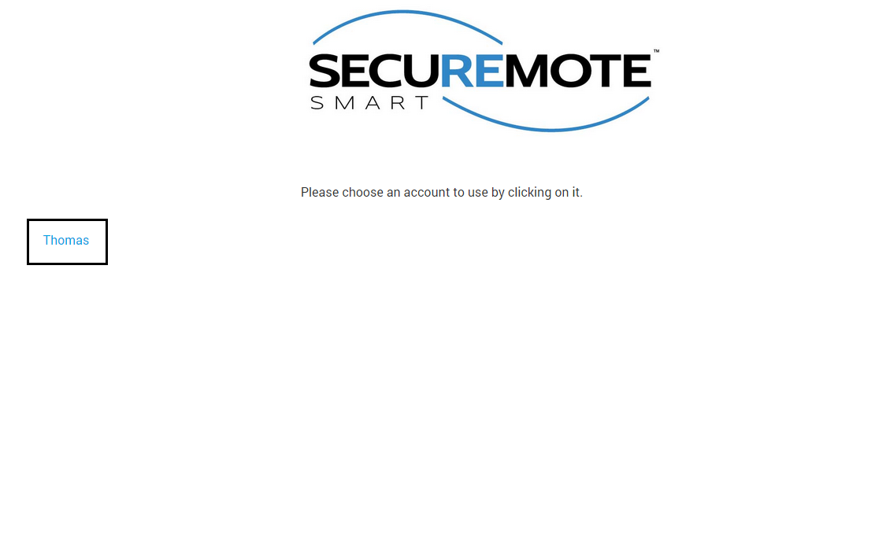

Figure 171: Registration Completed

## Sign-In Page

The e-mail address and password you used during registration are required to log-in to SecuRemote® Online. Your account must have been previously activated via the confirmation link sent to your e-mail.

You can choose to have your password reset by following the “Forgot your Password?” This requires you to know the e-mail address and last name used to register the account. An e-mail Message is then sent to you with a link that can be used to complete the password reset. Refer Figure 172 Figure 173.

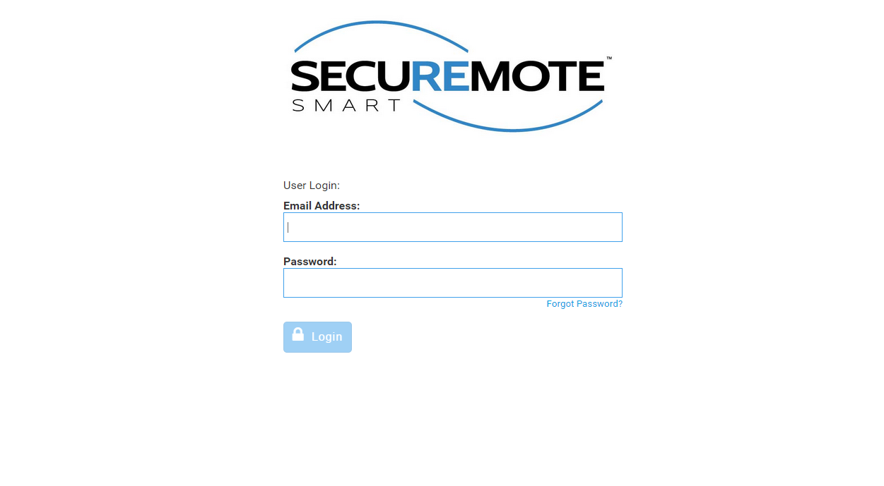

Figure 172: Sign In



Figure 173: Sign In

## Secure Home Page

Dashboard page will display with recent activities and welcome message. Refer Figure 174.

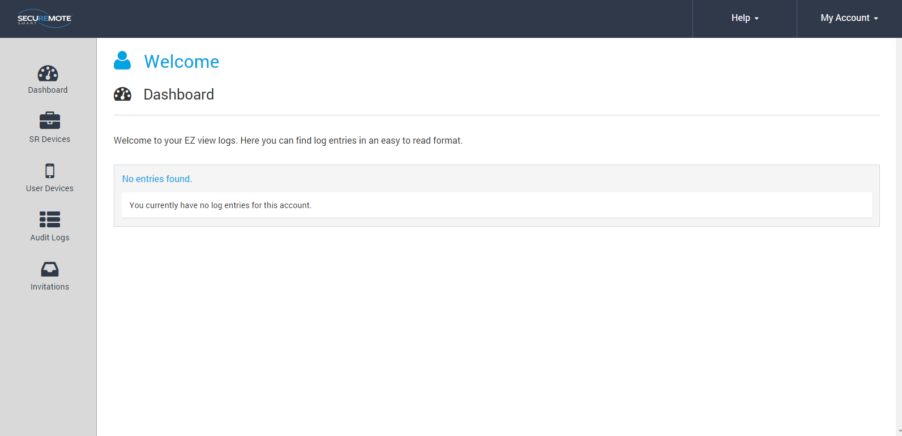

Figure 174: SecuRemote® Smart Home Page

## Register SR device

First user has to register the device from SecuRemote Smart™ Online site.

1. Select “SR Device” option and click on “Add SR Device”. Refer Figure 175.

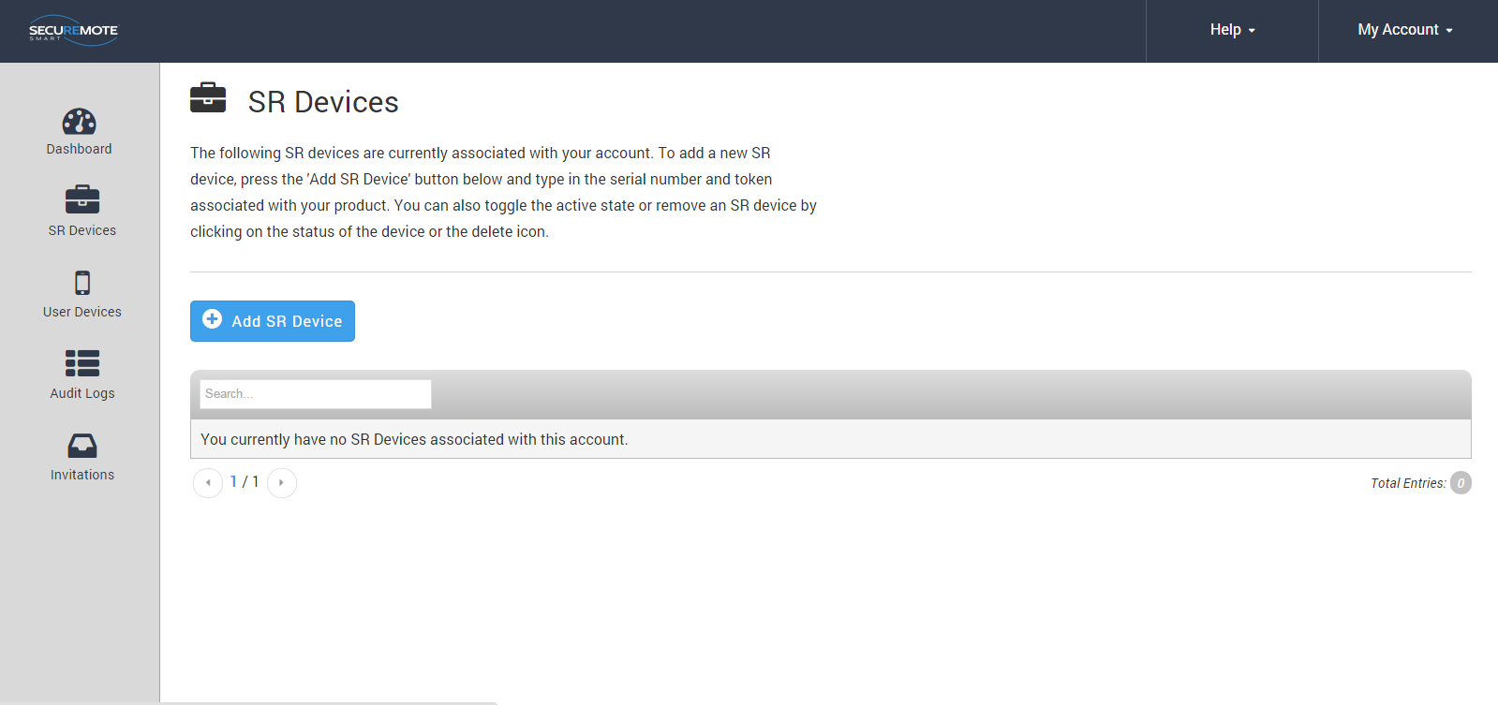

Figure 175: All devices

1. Requires entry of Serial number, Security token and Name of the SR KEELER and click on “Add SR Device”. Refer Figure 176.

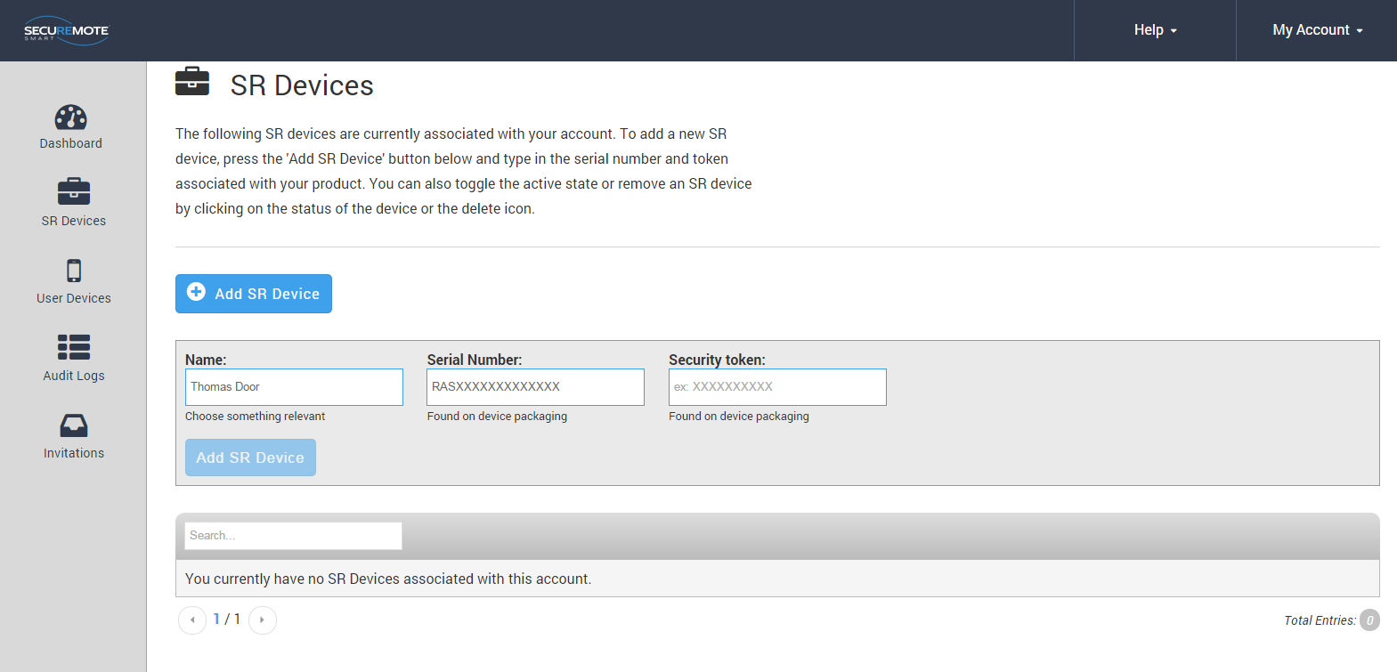

Figure 176: New device Registration

## All SR Devices

All devices belonging to the account are show in “SR Devices” screen. Refer Figure 177.

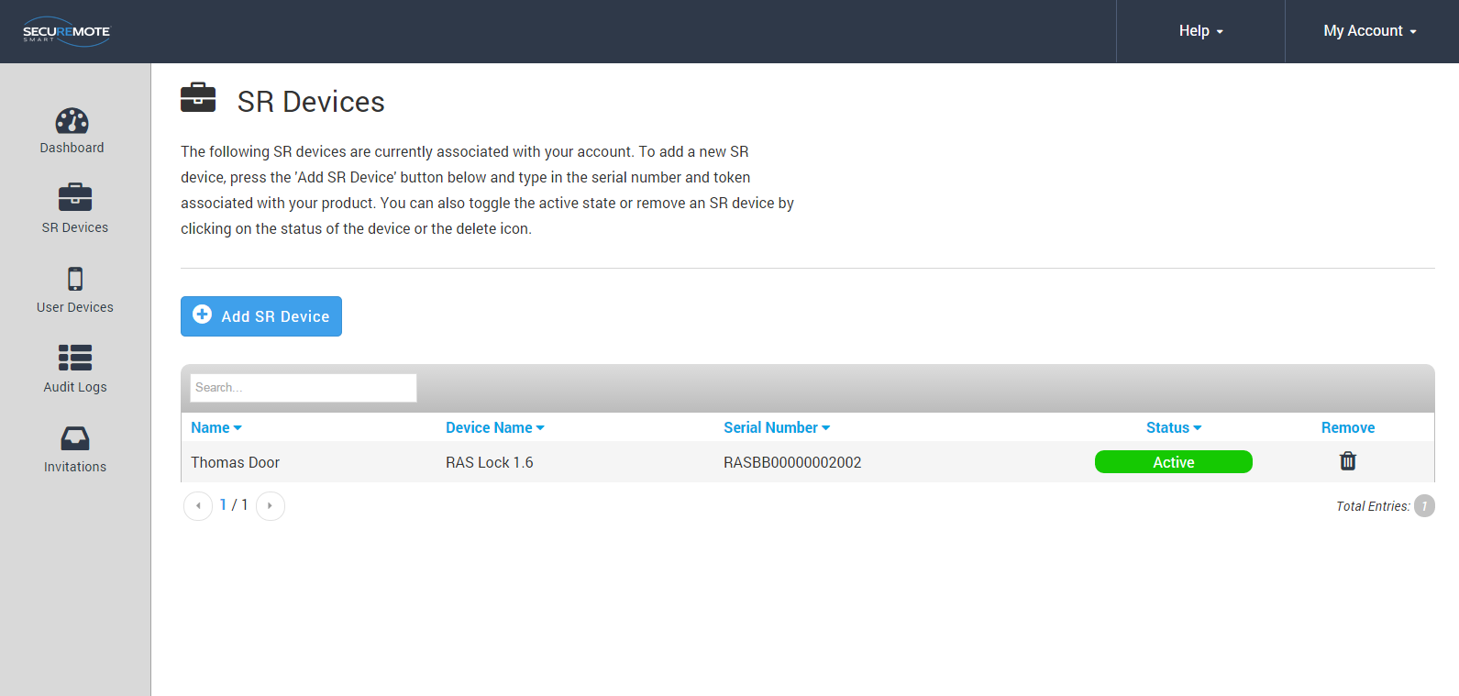

Figure 177: All devices

## 

## **Invite a New User Device**

Enter user name in the “Name” field and Click on “Request Invite Code”. You cannot enter a user with a name that already exist. Refer Figure 178.

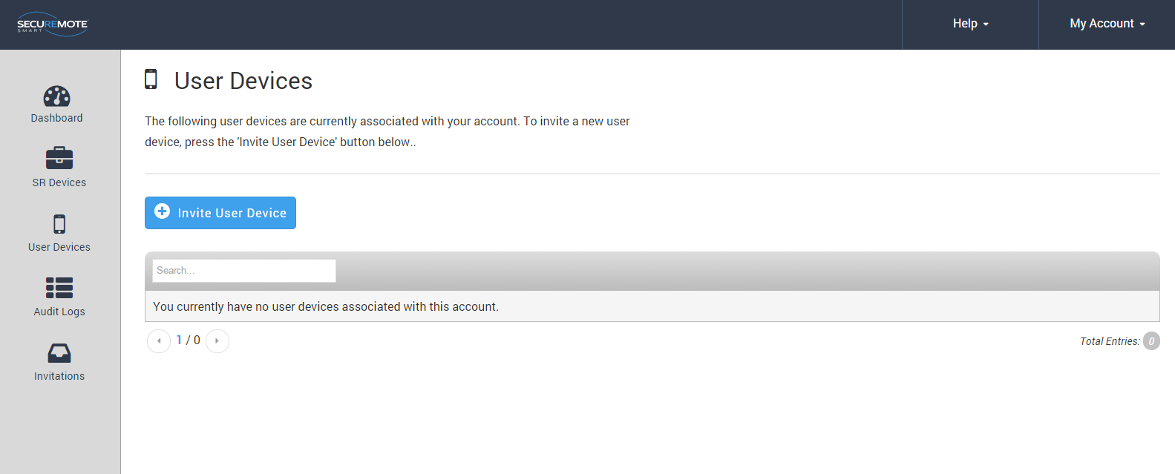

Figure 178: Invite a New User

New screen will show generated invited code and confirmation message will appear right hand bottom corner. Refer Figure 179.

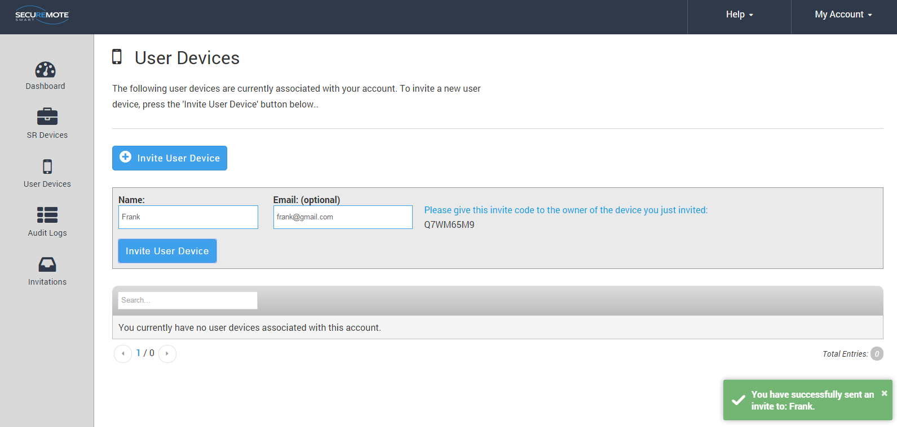

Figure 179: User Invitation

## **All Users**

1. The account administrator cannot be removed from the account.
2. Clicking on the user’s name brings up the “Edit user” dialog.
3. Security Link is an advanced security feature that allows the SecuRemote® Online service to uniquely identify a user’s smartphone. When a SecuRemote Smart™ app is run for the first time it generates a unique security token, a large random number that it sends to SecuRemote® Online every time an authorization request is made. This token must match the one used on previous requests in order for the request to be authorized. This ensures that no other smartphone can be used to initiate an authorization request on behalf of that user. Refer Figure 180.

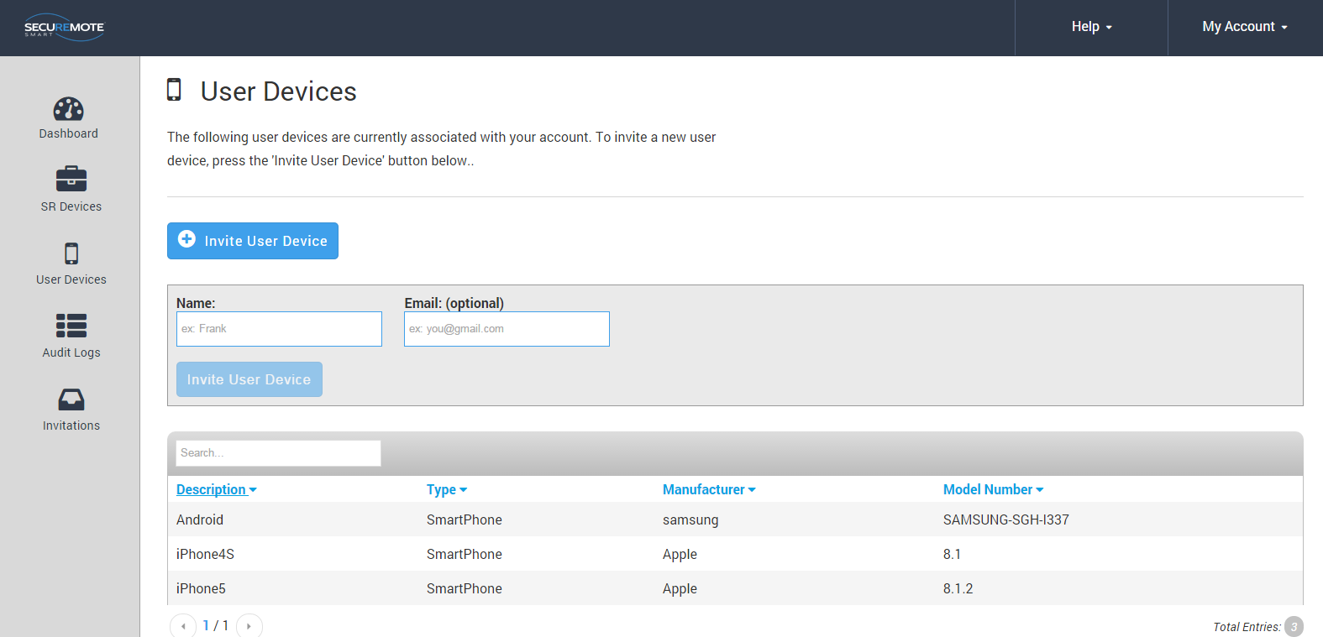

Figure 180: All Users

## **Audit Logs**

* 1. Audit log entries are shown in UTC by default on all accounts since it’s possible that they have multiple devices in different time zones.
  2. Audit logs are maintained for 365 days, the maximum length, by default for each account. The user can reduce this to as little as 7.
  3. Downloading the logs in Excel, CSV or XML format will download the entire audit log history. It is not affected by the filters used on the table above. Refer Figure 181.

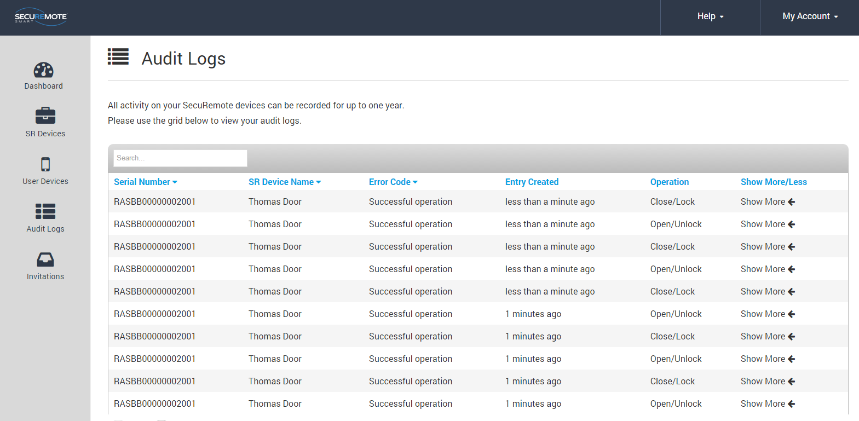

**Figure 181: Audit Logs**

## Register SR Bridge

Enter valid Serial number and click on Register Gateway.

Before registering the gateway user has to make sure gateway is powered on and connected with router through RJ 45 LAN cable.

Refer Figure 182 Refer Figure 183.

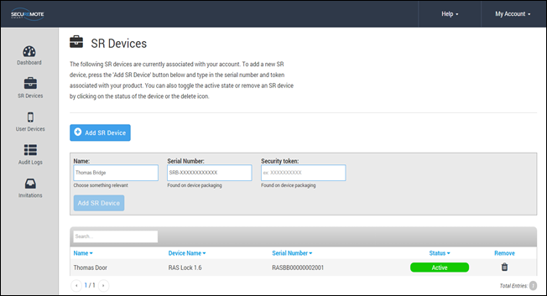

**Figure 182: New SR Bridge Registration**

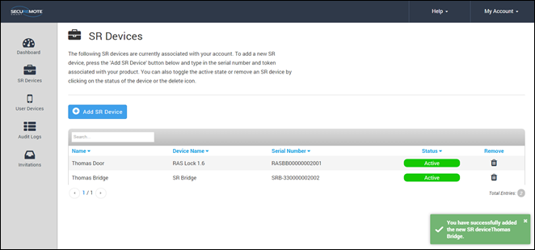

**Figure 183: New SR Bridge Registration**

## **Configure SR Bridge**

Click on manage option to assign SR Bridge to SR Keeler. Refer Figure 184.

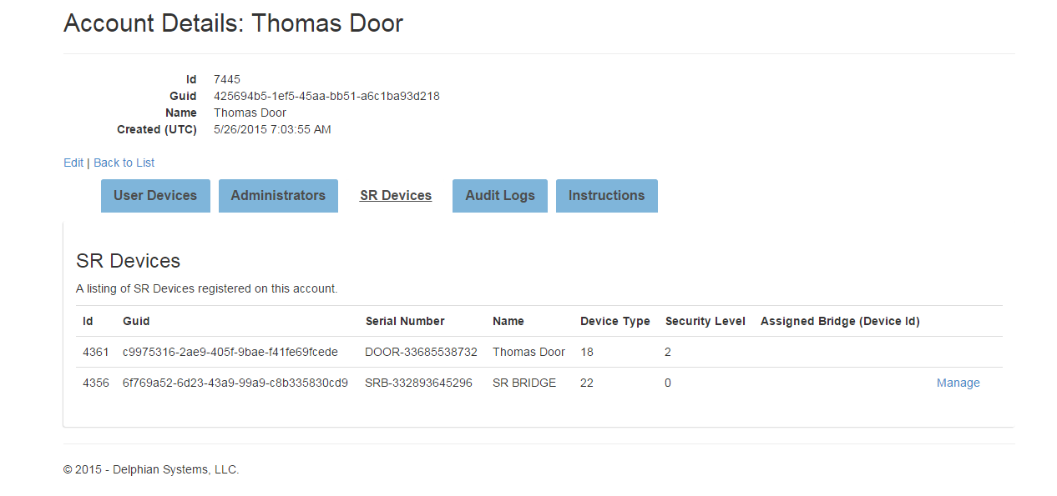

**Figure 184: Manage SR KEELER**

Please tick on device check box which you want to Configure. Refer Figure 185.

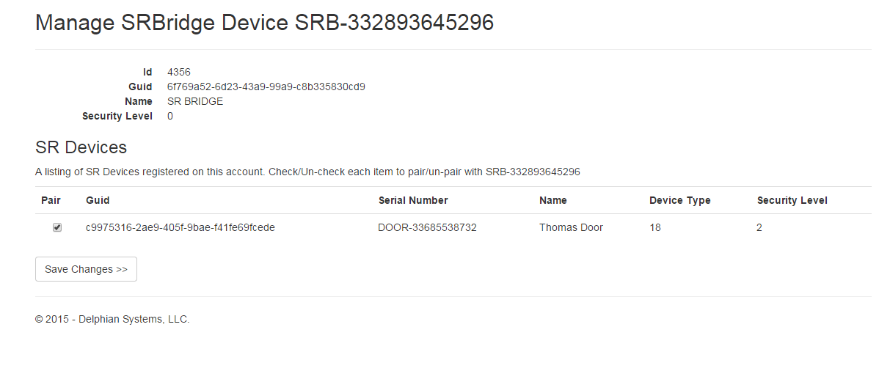

**Figure 185: Manage SR KEELER**

Selected device’s ID will show on the RAS device’s Assigned Bridge. Refer Figure 186.

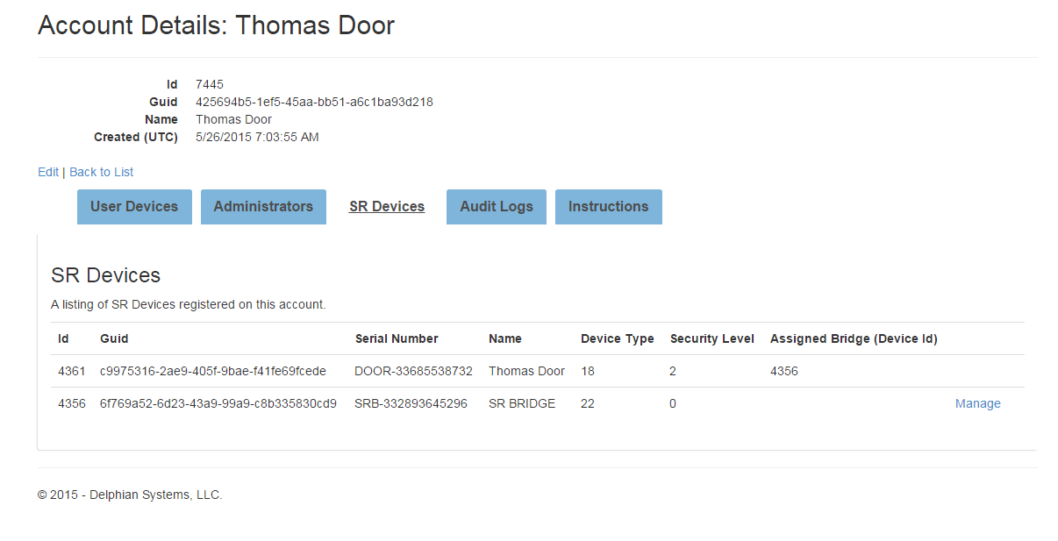

**Figure 186: Manage SR KEELER**

## **Dashboard Option**

This screen shows recent activities. Refer Figure 187.

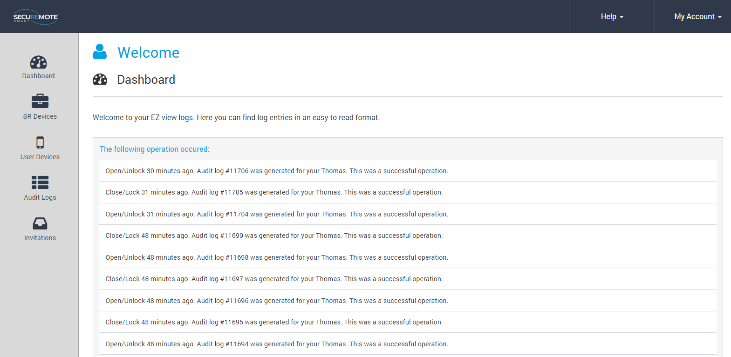

**Figure 187: Dashboard**

## **Invites Option**

This screen shows invitation send by users. Refer Figure 188.

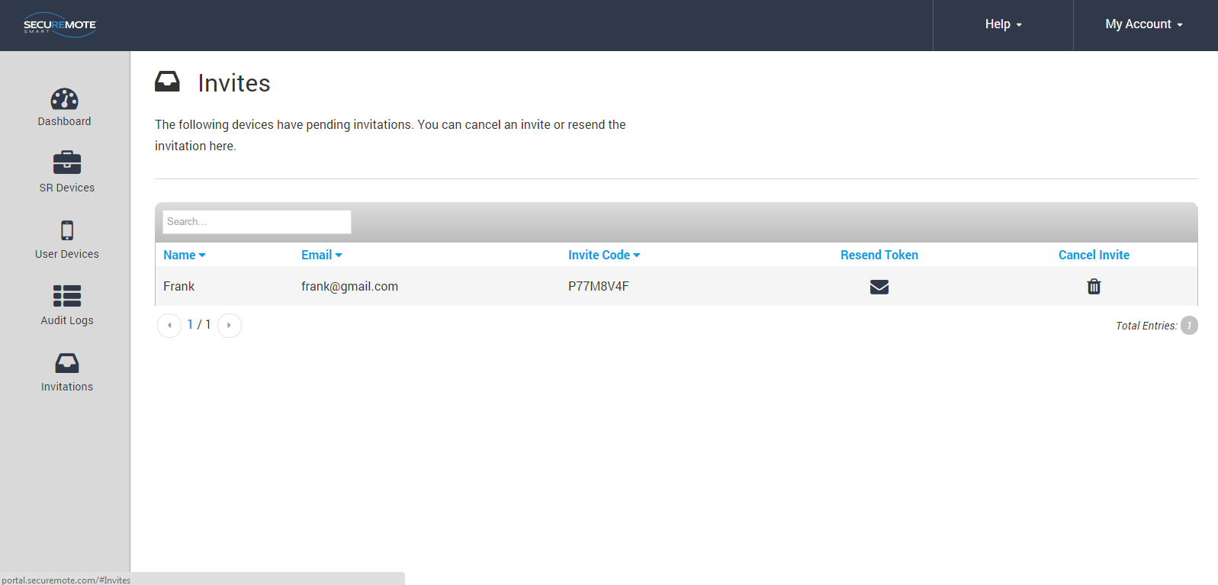

Figure 188: Invite Screen

# Remote Mode

This mode provide user to operate the device from remote location via internet connectivity.

User also has all the online mode features.

SR KEELER comes with built in SR Bridge CDMA module. For SR KEELER module user need to connect to power supply through adapter and it will automatically connect with register network. It will automatically enable remote operation once SR KEELER gets internet connectivity.



## **Lock operation**

1. Click on “Lock” button from Home Screen. Refer Figure 189.
2. “Safety Warning Reminder” message appears with “YES/NO” option. Click on “YES” option. Refer Figure 190.
3. Request sent to SR Portal “Toast Message” will appear. Refer Figure 191.

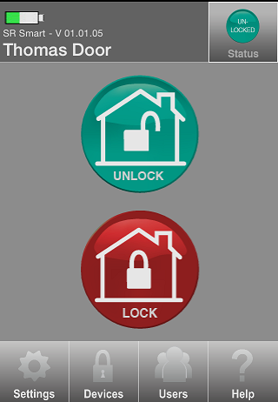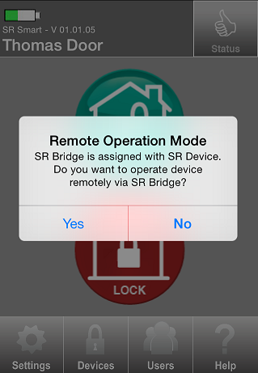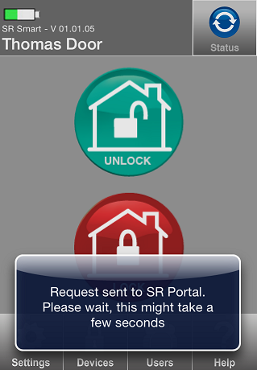

Figure 189: SR App Home Screen Figure 190: Safety Warning Message Figure 191: Request sent to SRO

1. “Lock” operation successfully performed message will appear. Refer Figure 192.
2. “Locked” status symbol will appear after the SR KEELER is “Locked” successfully. Refer Figure 193

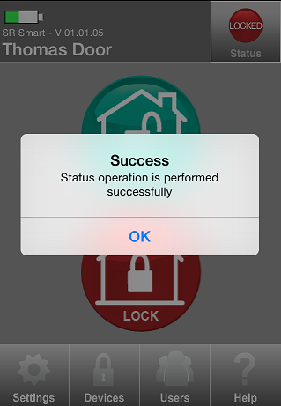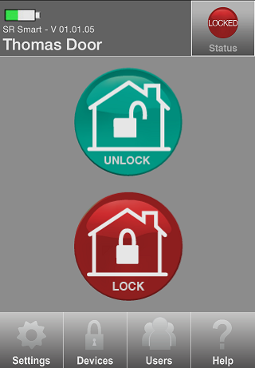

Figure 192: success Message  Figure 193: Home Screen

## **Unlock operation**

1. Click on “UNLOCK” button from Home Screen. Refer Figure 194
2. “Safety Warning Reminder” message appears with “YES/NO” option. Click on “YES” option. Refer Figure 195.
3. Request sent to SRO “Toast Message” will appear. Refer Figure 196.



Figure 194: Home Screen Figure 195: Safety warning Message Figure 196: Toast Message

1. “Unlock” operation successfully performed message will appear. Refer Figure 197.
2. “Unlocked” status symbol will appear after the SR KEELER is “Unlocked” successfully. Refer Figure 198

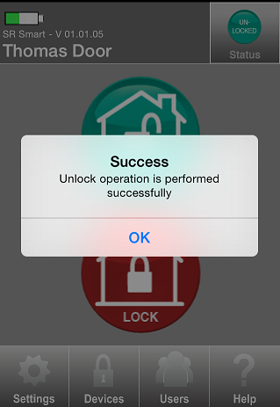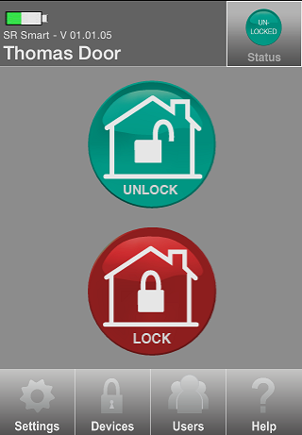

Figure 197: Success Message  Figure 198: Home Screen

## **Status operation**

1. Click on “STATUS” button from Home Screen. Refer Figure 199.
2. “Safety Warning Reminder” message appears with “YES/NO” option. Click on “YES” option. Refer Figure 200.
3. Request sent to SR Portal “Toast Message” will appear. Refer Figure 201.



Figure 199: Home Screen Figure 200: Safety warning Message Figure 201: Request sent to SRO

1. “Success” notification message will appear with “OK” option. Refer Figure 202.



Figure 202: Success Message

1. If the door is Unlocked then “Unlocked” will be indicated in Status. Refer Figure 203.
2. If the door is locked then “Locked” will be indicated in Status. Refer Figure 204.



Figure 203: Unlocked Status Figure 204: Locked Status

## **Remote Pairing**

Remote Pairing allows user to add SR device when it is not in Bluetooth range. User needs to enter invitation code to operate the device. The user can operate device only when device is added in SR Bridge. Remotely paired user cannot access settings of SR App.

To add user remotely follow the “Add User” steps.

# Update the SR Smart® App

## **Update the SR Smart® App for iOS devices**

Click on App Stores icon on your Home Screen. Click on “Updates” option in the bottom right corner. This will display any Apps that have updates available for your phone. To update the SR Smart App, select the SR Smart® App and click on “Update” option in the upper right corner.

## **Update the SR Smart® App for Android devices**

Update the SR Smart® App by setting your Android up for automatic updates. Click on the Android Play Store icon from your Home Screen. Click on “SR Smart®” and select “Allow Automatic Updating”.

# Remove the SR Smart**®** app from your Smartphone

**For iOS**

1. Tap and Hold on SR Smart App icon.
2. Click on Cross.
3. Message appears on screen with “Delete” and “Cancel” option.
4. Click on “Delete” option.

**For Android**

1. Go to phone “Settings”.
2. Click on “Application manager” option.
3. Select SR Smart app.
4. Click on Uninstall.
5. Message appears on screen with “Cancel” and “Uninstall” option.
6. Click on Uninstall.

# 

# Factory Reset

The user can set all parameters to Factory Reset default by pressing and holding the Factory Reset button for 5 seconds or more, located in the indoor unit of the SR KEELER. The user will need to remove the cover to access this button.

Note: Manual factory reset will keep one audit log for the same and user will get that log when he/she pair with SR KEELER first time after factory reset.

# SR KEELER LED Indication

|  |  |  |  |  |  |
| --- | --- | --- | --- | --- | --- |
| **SR.#** | **Event** | **LED1** | **LED2** | **LED3** | **DESCRIPTION** |
| **Red** | **Blue** | **Green** |
| 1 | Power ON | **B** |  | **S** | Once Red LED blink then Green Solid LED for 2 seconds then play “Power ON” |
| 2 | Factory Reset | **B** |  | **B** | 5 Times Red LED blink and wait 1 second then once Red LED Blink then once Green LED Blink then play “Power ON” |
| 3 | Pair |  |  | **B** | Three times Green LED blink and “Door is paired” |
| 4 | Lock |  |  | **S** | Green solid LED up to operation finished then play “Door is locked” |
| 5 | Unlock |  |  | **S** | Green solid LED up to operation finished then play “Door is Unlocked” |
| 6 | Auto Lock |  |  | **S** | Green solid LED up to operation finished then play “Door is locked” |
| 7 | Status |  |  | **B** | Green led blink once |
| 8 | Lock Error | **S/B** |  | **S** | Green solid LED display up to motor stop then Solid Red for 2 second and Twice Red LED Blink again then play “Lock Error” |
| 9 | Unlock Error | **S/B** |  | **S** | Green solid LED display up to motor stop then Solid Red for 2 second and Twice Red LED Blink again then play “Lock Error” |
| 10 | Deadbolt Jammed (Current status is Unlock and do Lock) | **S/B** |  | **S** | Green solid LED display up to motor stop then Solid Red for 2 second and Twice Red LED Blink again then play “Deadbolt jammed, door is unlocked” |
| 11 | Deadbolt Jammed (Current status is lock and do unlock) | **S/B** |  | **S** | Green solid LED display up to motor stop then Solid Red for 2 second and Twice Red LED Blink again then play “Lock Error” |
| 12 | BLE connection |  | **B** |  | Blink Blue led every 500 ms till connection |

# 

# 

# Keyfob LED Indication

|  |  |  |  |  |  |
| --- | --- | --- | --- | --- | --- |
| SR.# | **EVENT** | **LED1** | **LED2** | **LED3** | **DESCRIPTION** |
|  |  | Red | Blue | Green |  |
| 1 | Keyfob Power ON. | B | B | B | Blink Red , Blue and Green simultaneously 1 time |
| 2 | Press and hold any key for more than 5 seconds. | B | B |  | Blink Red and Blue LED till connection with Smart phone or Configuration mode timeout (30 seconds) |
| 3 | connected with smart phone |  | B |  | Blue LED blinks continuously until disconnection from Smart phone |
| 4 | SR keyfob configured successfully |  |  | B | Blink Green LED three times |
| 5 | SR keyfob configuration failed | B |  |  | Red LED blinks twice |
| 6 | Press button to operate(open/close) |  |  | B | Green LED blinks until operation is completed |
| 7 | Out of bluetooth range | B |  | S | Green LED solid and Red blinks 4 times |
| 8 | Notification error | S |  | B | Red LED solid and Green blinks 4 times |
| 9 | Operation successful |  |  | S | Green LED solid for 2 seconds |
| 10 | User Not found |  | B |  | Blue LED blinks twice |
| 11 | Session ID mismatch | B |  | B | Red and Green LED blinks 3 times |
| 12 | Pairing FaiLED | B |  | B | Red and Green LED blinks 4 times |
| 13 | Operation timer expired | B |  | B | Red and Green LED blinks 5 times |
| 14 | Switch error in SR device | B |  | B | Red and Green LED blinks 6 times |
| 16 | Advertisement error | S |  |  | Red solid for 3 seconds |
| 17 | key not configured with any SR device | B |  |  | Red LED blinks 2 times |
| 18 | Error in connection | B |  |  | Red LED blinks 3 times |
| 19 | Low Battery indication | B |  |  | Red LED blinks 5 times |

# Frequently Ask Questions

1. I am not able to connect with an SR device in Local Mode. What should I do?
2. Make sure your smartphone Bluetooth is turned ON, the SR device is powered ON, and that both devices are within direct operation range.
3. Turn OFF Bluetooth of your smartphone and Turn ON again.
4. How do I set Administrative PIN?

User can change Administrative PIN any time.

1. Launch SR Smart App.
2. Select “Settings” -> “SR App Settings”.
3. Click “Set Admin PIN”.
4. Enter current Administrative PIN when prompted.
5. Enter your new Administrative PIN, Confirm Administrative PIN and press “SAVE” button.
6. How can I set User PIN?

User can change User PIN any time.

1. Launch SR Smart App.
2. Select “Settings” -> “SR App Settings”.
3. Click “User PIN”.
4. Enter current Administrative PIN when prompted.
5. Enter your new User PIN, Confirm User PIN and press “SAVE” button.
6. How do I add SR devices?

Make sure your smartphone Bluetooth is turned ON, the SR device is powered ON, Mobile Data is turned ON and that both devices are within direct operation range.

1. Go to the SR App “Devices” menu.
2. Click on “Add devices” option.
3. Click on “Scan QR Code” or Enter SR# manually.
4. Fill Mandatory information and click on “Create New Account”.
5. Enter Email ID, Password, “User Name” and click on “Register SR Device” button.
6. How can I operate an SR device within SR Device range?
7. Make sure your smartphone Bluetooth is turned ON, the SR device is powered ON, and that both devices are within direct operation range.
8. Verify that you have successfully paired with the SR device and that the device you want to operate is shown on the upper left of SR Smart App home screen, if not the select it from the “Devices” menu.
9. Press any of the operation buttons shown on the SR Smart App home screen.
10. Cannot able to operate an SR device within SR Device range, what do I do?
11. Make sure your smartphone Bluetooth is turned ON, the SR device is powered ON, and that both devices are within direct operation range.
12. Turn your smartphone Bluetooth OFF and ON again.
13. If you are not an authorized User, please contact the Administrator of that device for more information.
14. How do I check the device status?
15. Make sure your smartphone Bluetooth is turned ON, the SR device is powered ON, and that both devices are within direct operation range.
16. Launch the SR Smart App and press “Status” button at the right-top corner of the SR Smart App home screen.
17. How to switch between SR devices?
18. Launch the SR Smart App and go to the “Devices” menu.
19. Select the SR device from the device list.
20. How can I rename an SR device?
21. Go to the SR Smart App “Settings” menu.
22. Click on “SR Device Settings” menu.
23. Click on “Device Name”.
24. Enter new name of device and then press “Save” button.
25. How can I delete an SR device?

Make sure your smartphone Mobile Data is turned ON.

1. Go to the SR Smart App “Settings” menu.
2. Press the “Delete SR Devices” option.
3. Press “Yes” button from “Removing SR Device” message.
4. How can I add a new user?

Make sure your smartphone Mobile Data is turned ON.

1. Go to “Users” option of the SR Smart App.
2. Enter current Administrative PIN when prompted.
3. Click on “Invite Access Device” option.
4. Enter Email ID, password when prompted and click on “Validate Details” option.
5. You can add a user by using any of the following options:

* Select from Contacts: You can select contact from Phone book directly.
* Type In: You will need to enter user information manually.

1. Click on “Get Invite Code” option.
2. You will be asked to send an SMS to the user. If you want to inform this user that he/she is authorized to operate this device and prompt them to download the SR Smart App from the embedded link press “YES” otherwise press “NO” button. Note: This option is available only on cellular enabled devices. Standard SMS messaging rates may apply.

* Type In: You will need to enter user information manually.

1. Click on “Get Invite Code” option.
2. You will be asked to send an SMS to the user. If you want to inform this user that he/she is authorized to operate this device and prompt them to download the SR Smart App from the embedded link press “YES” otherwise press “NO” button. Note: This option is available only on cellular enabled devices. Standard SMS messaging rates may apply.
3. How to delete user SR App?

Make sure your smartphone Mobile Data is turned ON.

1. Go to “Users” menu of the SR App and select the user from the user list.
2. Click on “Delete Access Device” option.
3. Enter Email ID, Password when prompted and click on “Validate Details” option.
4. Use will be deleted.
5. How do I add a user using the SR Portal?

Log in to your existing SRO account by visiting [https://www.securemoteonline.com](https://www.securemoteonline.com/). If you have not created an SRO account yet, please register by visiting <https://www.securemoteonline.com/Account/Register>.

1. Go to “User Devices” option from SR Portal.
2. Click on “Invite User Device” and manually fill the information and click on “Invite User Device”
3. “Invite Code” will display on SR Portal.
4. What does “Accept Invitation” mean?

In order for a new user to operate a device that the Administrator has authorized them, the user must first accept the invitation sent to them via email or SMS. The invitation Message also contains the Invitation Code, a 7-digit code, that the user will be prompted to enter upon setting up the SR App or attempting to pair with the SR device that has been authorized to operate.

1. Why the SR App is unable to operate an SR device from SRO?

Make sure you have Internet Connectivity and that your SR device and SR Bridge are powered ON.

1. How do I get status of SR device at remote location?

Press the “Status” button shown at the right-top corner of the SR App home screen.

1. What if “You forgot to lock the door” notification receive by user?

Notification alert which is triggered if you have forget to lock door and moved a mile away from the SR device location. This is accomplished by SR tracking both the SR device status and your approximate location by using your Smartphone's Location Services.

1. How do I enable notification if I forgot to lock the door?

Once you have registered an SR Bridge with SRO, the SR App will automatically detect the SR Bridge and it will enable this notification functionality for SR devices that support it (SR Locks and Door devices) provided that you have enabled your Smartphone’s Location Services and have authorized the SR App to use them.

**For iPhone:**

1. Make sure you have enabled Location Services and had given permission to the SR App.
2. You can enable Location Services using iOS Settings>Privacy>Location Services.

**For Android:**

1. Make sure you have enabled GPS/Network Provider Enabled.
2. You can enable GPS/Network Provider using Settings>Location Services.

**To mark the SR device location:**

1. If you want to manually enable the “Doors Unintentionally Left Open or Unlocked” notification, go to Settings> Security Settings>SR Gateway.
2. Press “Set Location” and make sure you are within range of the SR device.
3. How accurate and reliable is the “Doors Unintentionally Left open or unlocked” notification?

The accuracy of your location depends on the type of Location Services used by your Smartphone and the speed at which you are moving away from your home/office (SR device location). When a door is left open/unlocked SRO will request your location from the SR App and will trigger the notification alert once your physical distance has exceeded

a mile from the device. Your exact physical distance at the time the notification alert Message is shown on your Smartphone screen will depend on the GPS connectivity and speed at which you are driving away - it will typically be about a mile. For iPhone users, please make sure you keep your Wi-Fi always ON. For more accurate results iPhone will use public Wi-Fi networks to calculate your current location. The notification is very reliable as long as your Smartphone Location Services are enabled and the SR devices are powered ON.

1. I am the Administrator and have lost my phone. How do I set my new phone as Administrator to the SecuRemote® device?

Do a factory reset of the SecuRemote® device by pushing and holding the reset button using a paper clip until blue light starts to flash, then release the button. This will delete all direct users from the SecuRemote® device and reset the Administrator password and save the Bluetooth® PIN as “1234”. Download and install the SecuRemote® App to the smartphone. Start the App and finish pairing with the SecuRemote® device. This will establish the new phone as the administrator again. The User needs to re-enter all direct users to the SecuRemote® device again. As the SecuRemote® device is defaulted to factory re-set, all direct and online users need to pair with the SecuRemote® device using the pairing option.

1. One of the direct users lost his/her phone. How do I delete direct user from SecuRemote® Device so this phone cannot access the device anymore?

Any direct user with unlimited privilege can delete this user from the SecuRemote® device using delete option under user list. This is verified through the Administrator password so the user needs to know the Administrator password.

1. A user forgot the Administrator password and how do I reset it?

User needs to delete the SR App and install new app and user default password”1234”.

1. I received an error for “maximum allowable users are added” when trying to add new user.

SecuRemote® allows a maximum of 10 users including the Administrator. If the Administrator wants to add a new user, the Administrator needs to delete any existing user or edit any existing user with the new user information.

1. My iPhone® shows that the Bluetooth® is connected but the SecuRemote® device shows that the device is not connected.

This is an issue with the Bluetooth® functionality of your iPhone®. Turn the Bluetooth® off and then on from the Bluetooth® from the Bluetooth® setting screen. Now try to re-connect your Bluetooth®. Please refer to your smartphone user manual for further information.

1. How to activate GPS/Location Services in Smartphone?

iOS:- Settings-Privacy Location services SecuRemote®

Android: - SettingsLocation Services Enable Use GPS satellites

1. How family member can inherit admin access?

When any family member will Scan QR Code and add device in his smartphone then family member can inherit Admin access.

1. How Auto Lock Timer feature will work? User don’t need to press latch to auto lock?  
     
   Keeler Lock will automatically go in Lock State on pressing of Auto lock switch (wake up switch) and pressing latch on device after selected timer device should automatically lock. Auto lock feature will be enable by Default. Default value for Auto Lock is 2 sec. Follow the below steps to enable Auto Connect feature.
2. Launch SR Smart App, Press ***Settings -> SR Device Settings -> Select Auto Lock Time from Auto Lock Timer Listing*** option.

***NOTE - It will ask for Admin PIN as well. This option is only visible to admin user not for invited user.***

1. Press ***Save*** button.
2. How Audio Message feature will work?  
     
   If this feature is enabled then SR Device will play audio sound on performed actions on in it. For example on lock operation audio message will be Door is locked. Follow the below steps to enable Audio Message feature.
3. Launch SR Smart App, Press ***Settings -> SR Device Settings -> Select Audio Enable Switch***option.

***NOTE - It will ask for Admin PIN as well. This option is only visible to admin user not for invited user.***

1. Press ***Save*** button.
2. How many users can be added to a Keeler Lock?  
     
   Maximum 10 user can added in Keeler lock.